
Forty Hill C.E Primary School
Relationships and Conduct Policy
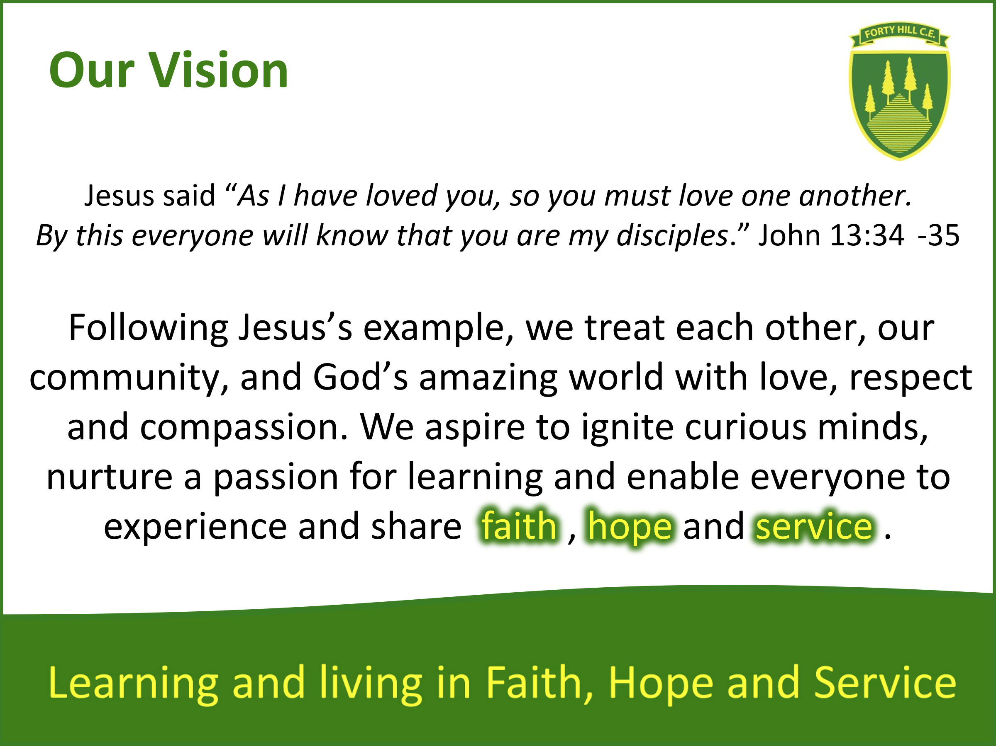
Our Vision and Values
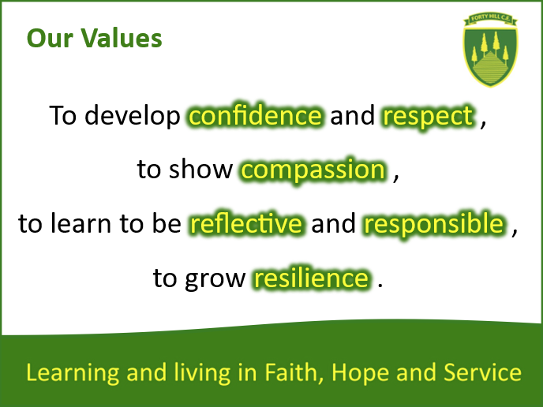

Intent
At Forty Hill CE School, we believe that every member of the school community is of equal importance in the eyes of God. Our school’s theologically rooted Vision and Values, which are agreed by pupils, staff, parents and governors, allow us to work in harmony with one another and ensure safety and wellbeing for all within the school community.

Furthermore, we believe that the establishment of a good learning environment both within and outside the classroom is key to effective education. Effective teaching and learning is dependent on positive relationships established at a school and classroom level through interactions between staff and pupils and between pupils themselves.
We believe it is crucial for parents to embrace, and model, our school values and appropriate behaviours.
At Forty Hill, our mission is to foster a Christ-centred community where each child is nurtured, valued, and encouraged to flourish. We believe in building positive relationships based on Christian values of love, respect, compassion, and forgiveness. Our Relationships and Conduct Policy outlines our approach to maintaining a supportive and safe environment for all students, integrating Restorative Justice principles and Trauma-Informed Practices.
Aims
- To promote a positive and inclusive school culture rooted in Christian values.
- To address conflict and conduct issues through restorative and supportive means.
- To recognise and respond to the impact of trauma on student behaviour and well-being.
- To create an atmosphere of mutual respect, trust and responsibility
- To build self-esteem and positive attitudes to ensure that all pupils feel of equal value
- To build a culture of self-regulation and emotional literacy.
- To promote a positive school ethos through supportive behaviour strategies and celebrations of children’s successes across their school life.
- To work collaboratively with parents, pupils and staff in setting expectations of relationships and conduct within the school
- To take firm action against bullying, racism, homophobia or any kind of derogatory conduct towards protected characteristics.
- To develop pupils’ awareness of Christian and British values to enable them to understand their role in the world they live in.

Implementation
Managing Relationships and Conduct at Forty Hill
We believe that good relationships and conduct should be automatic and are the responsibility of the individual. Positive relationships and conduct should be demonstrated by all those associated with the school.
We accept that, at times, pupils will deviate from expected standards of conduct. This normally falls into three areas:
- High spirits resulting in a lack of judgment or consideration for others - this can usually be dealt with swiftly by a calm conversation or non-verbal communication.
- Break down in the relationship between pupils resulting in a negative response from one or both pupils – this usually requires a more considered conversation and an opportunity to reflect
- Failure to demonstrate the school values resulting in putting themselves or others at risk (this covers a range of behaviours)– this is the most serious breach of the Relationships and Conduct Policy. Parents will be informed of the incident and the outcome. The school reserves the right to exclude pupils (internally, or externally for a fixed term or permanently) who persistently defy the policy in this manner or, in the case of a parent, to ban them from the school site.
Responsibilities
- Governors: have a responsibility for monitoring the ethos of the school and the Senior Leadership Team have overall responsibility for establishing the ethos and for supporting staff in achieving positive behaviour.
- Staff, both teaching and non-teaching, share a responsibility for consistently implementing expectations of positive behaviour. All staff members are expected to model Christian values in their interactions, support restorative practices, and respond to student behaviour in a trauma-informed manner. Ongoing professional development in these areas will be provided.
- Pupils: Students are encouraged to take responsibility for their actions, participate in restorative processes, and support their peers in maintaining a positive school environment.
- Parents: Parents have a responsibility for ensuring that they support their child in meeting school expectations in respect of positive relationships and conduct, and they model appropriate behaviour in their dealings with the school. This always includes treating school staff with respect. Parents are partners in their child’s education and well-being. We encourage open communication between home and school and will invite parents to participate in restorative processes when appropriate.
- Leadership Team: The leadership team will oversee the implementation of this policy, ensure staff receive necessary training, and monitor the effectiveness of restorative and trauma-informed practices.
Our Positive Ethos for Relationships and Conduct
Consistency and a supportive environment are the keys to success.
At Forty Hill:
- We set clear and consistent expectations in a positive way
- We support our children using the Zones of Regulation and the toolkits associated with each zone
- Where appropriate, we encourage our children to use their individualised toolkits independently
- We focus on identifying the root cause for the poor relationship and conduct, and support children to make amends and move forward, learning from this experience. This includes considering reasons for poor conduct and relationships through trauma informed practice.
- We recognise, praise and reinforce appropriate behaviour
- We allow time for children to calm down and regulate following an incident before having a restorative conversation.
- We encourage the child to seek help and ensure that they always know who is available to help them (e.g. friend, duty staff, class teacher, pastoral lead, senior staff, Vicar)
Working in partnership with parents
We recognise that parents have a considerable influence upon their child’s relationships and conduct and play a vital role in ensuring their child is able to have a successful and positive day at school. We know that establishing an effective working partnership will positively affect standards of relationships and conduct.
At Forty Hill:
- All members of the school community are expected to respect each other and show consideration for others beyond themselves
- Parents should encourage their children to respect and value each other, school staff, equipment and God’s world
- Parents have a responsibility to ensure their children do not bring any potentially dangerous objects to school that could harm themselves or others, including food items that could result severe allergic reaction.
- Parents should ensure their children understand that they must remain on the school grounds during the normal school hours
- Parents should model our school Vision and Values when interacting with each other, staff and pupils.
- We are aware that parents occasionally hear ‘snippets’ of the school day that are not always in context or reflective of the full events of a situation. We aim to communicate the ‘full picture’ through open dialogue and positive relations that harbour parental trust in the school system to proactively resolve issues.
Recognising good relationships and conduct
The following is a guide to some of the positive strategies the school staff and pupils can employ to reward, recognise and encourage positive relationships and conduct. These cover all aspects of school life.
- Awarding values, achievement and star of the week certificates, table/group points, house points, Values awards/nominations, certificates and stickers, including our values stickers, for positive relationships and conduct, and achievement in areas across the curriculum and out of school
- Recognition of excellent relationships and conduct in the classroom and school environment through class ‘Star Jars’ in every year group. Achieving 20 stars as a class will result in a class treat.
- Use of PSHE, ‘Circle Time’ and R.E. to discuss aspects of personal and social development including positive relationships and conduct.
- Religious Education lessons to discuss Christian Values, the teachings of Christ and tolerance and respect of others’ beliefs or non-belief
- Discussing whole school relationship and conduct at School Council meetings to ensure pupil voice and input
- Consistent use of positive praise by all staff as a sincere and prompt response to positive relationships and conduct or achievement
- ‘Good News’ postcards sent home to share achievements that demonstrate our Vision and Values in action
- Giving positive feedback to individuals about their work/conduct/relationships
- Showing work to others, including older children, other teachers and the headteacher
- Whole school Collective Acts of Worship on the School and British Values, the teachings of Christ and moral and social issues
- If needed, setting of personal and class targets for improving work, relationships and conduct through restorative conversations and strategies
Zones of Regulation
At Forty Hill we use the Zones of Regulation to support our children in making choices. We encourage our children to understand and identify their emotions and in turn, the tools that support them in dealing with their feelings in an appropriate and effective way. Our aim is that through understanding and managing our feelings, we can in turn regulate our choices and behaviour. Our children are familiar with the green, red, blue and yellow zones. We encourage our staff and children to use this terminology when approaching discussions around emotions as a shared and common language making discussion accessible to all. Our children are also explicitly taught about toolboxes for coping in each zone with the end goal of being ready to learn. We offer our children a range of strategies for their ‘toolboxes’, encompassing sensory supports, thinking strategies and calming techniques.
Restorative Justice Approach
Restorative Justice is central to our approach in managing behaviour and relationships within the school. We focus on repairing harm, restoring relationships, and reintegrating students into the school community. Key elements include:
- Restorative Conversations: When conflicts arise, students involved will engage in facilitated discussions to express their feelings, understand the impact of their actions, and work towards reconciliation.
- Circle Processes: Regular circle times will be held to build community, strengthen relationships, and address issues collaboratively. Circles encourage open dialogue and shared responsibility.
- Repairing Harm: Students who cause harm are supported in understanding the impact of their actions and are guided to make amends. This may include apologies, completing a restorative community task, or other actions agreed upon during restorative conversations.
- Reintegration Support: For students who have been involved in serious conflicts or have faced disciplinary action, we provide a structured reintegration plan to help them reconnect with their peers and continue their education in a positive manner.
Trauma-Informed Practices
Recognising that some students may have experienced trauma, we are committed to adopting practices that acknowledge and address the impact of trauma on behaviour and learning.
Our approach includes:
- Safety and Trust: We create a physically and emotionally safe environment where students feel secure. Clear expectations, consistent routines, and trustworthy relationships are emphasised.
- Empathy and Understanding: Staff are trained to recognise signs of trauma and respond with empathy. We understand that behaviour may reflect past experiences and focus on understanding the underlying causes rather than solely addressing symptoms.
- Collaborative Problem-Solving: We involve students in decision-making processes, giving them a voice in how conflicts are resolved and in the development of strategies to support their well-being.
- Flexible Support: Individualised support plans are developed for students affected by trauma. This may include counselling, mentoring, or adjustments in the classroom environment to meet their needs.
-Children’s poor conduct is never highlighted publicly e.g standing them up or writing their name in public view, conversations and reminders are discreet and calm
-School staff must ensure they are regulated prior to having a conversation about conduct with a child. Conversations about conduct should be addressed calmly with both staff and pupils feeling regulated.
-We strive to be a ‘no shouting’ school, adults are role models for self-regulation and calm.
Adapting the Policy for EYFS
We recognise that our youngest children may find regulating their behaviour more challenging and
are learning the new rules and routines of Nursery and Reception. In line with the EYFS curriculum, a
primary focus will be on developing these routines, simple restorative conversations, identifying different
emotions and strategies for self-regulation.
Pupils with SEND
As an inclusive school, we recognise that relationships and conduct can be different for all pupils. For pupils with Special Educational Needs, an adapted approach is often needed, taking into consideration the individual pupil’s barriers that may affect their relationships and conduct. Restorative discussions may take a different format dependent on the incident or needs. The Headteacher and/or SENDCo will determine the outcome of the discussion and future steps to support the child. All children are dealt with on an individual basis. An individual behaviour plan may need to be created to support the child and their understanding of expectations.
Incident logs
At Forty Hill a variety of different logs are kept recording the following:
- Any incident involving a child, or anyone employed at the school, which results in personal injury
- Aspects of bullying (including cyber-bullying), racism or any derogatory conduct towards protected characteristics.
- Any incident which results in a decision to make a phone call/email to the parents will be recorded in the class record book by the class teacher.
- Any incident which results in involvement of SMT (Senior Management Team) and/or a meeting with parents (this could be hurting, fighting, swearing, derogatory language, vandalism, over-aggression, disrespect to adults etc) on our MIS system.
- Any behaviour incidents that raise safeguarding concerns e.g. sexual language on Safeguard.
- Any contact about pupils from outside agencies
These logs will be recorded by a member of school staff and are all dated, indicate people involved, relevant information and action taken. The logs are held on our online Management Information System and reported to Governors termly and Ofsted in the event of an inspection.
Smaller issues regarding relationships and conduct, are a normal part of child development and are dealt with appropriately by our experienced staff, with no need to record or report to parents. Self-regulation is one of the key milestones for child development, and this involves making mistakes and learning from them.
Use of Physical Restraint
If a pupil becomes physically aggressive towards another pupil or member of staff and will not refrain from dangerous conduct after being given time and support to calm down and regulate, or if the pupil is likely to cause physical injury to others or him/herself or damage property, staff may use an acceptable level of restraint. Please see our Positive Handling Policy for further information. This is always the last resort.
Our Relationships and Conduct Strategy
Yellow Card Incidents
Whilst we strive for positive relationships and conduct at all times, there will inevitably be times when we have to support children further in this area at Forty Hill.
In class, this might be minor activity which can have a disruptive effect, for example: wandering about, calling out, interrupting other pupils, “fidgeting” with equipment, or deliberate non co-operation.
Outside the classroom, this behaviour may include but is not limited to: persistently pushing or pushing in when lining up, answering adults back when spoken to, ignoring or walking away from staff, time-wasting, refusing to listen to staff or not demonstrating our school values (particularly Respect and Compassion).
We believe these issues can be addressed by all staff members using positive reinforcement. However, there are times when a different approach is required. This includes but is not limited to:
- Initially a quiet conversation to remind pupil of class expectations and school Values
- Change in seating arrangements within the classroom
- If the verbal warning and other strategies has had no effect, a yellow card will be recorded in the class book and the child will be discreetly informed of this consequence.
- A restorative conversation with the child and anyone affected by their conduct
- A reparative action to rectify the issue during their own time (break or lunchtime)
- A phone call or email to parent(s) to work together to reinforce positive relationships and conduct
If the pupil receives two yellow cards in a one-week period, the second card becomes a red card (see below).
Red Card Incidents
Unfortunately, there may be times when serious incidents occur that require greater attention and the need for an additional consequence. This includes but is not limited to:
- Bullying, severe intimidation and tormenting
- Deliberate use of obscene or improper language, including discriminatory or derogatory language, intended to hurt feelings or offend
- Racial, social, cultural, disability or religious abuse/behaviour
- Stealing
- Deliberate vandalism of school property
- Rudeness/non co-operation with adults where positive praise and reinforcement from the member of staff has been exhausted
- Fighting with or hurting others including any form of hitting
- Leaving school without permission
- Refusal to follow instructions, which put the child or others at risk
- Sexual harassment or abuse
All incidents are dealt with from a trauma informed perspective with a restorative justice approach. This means we take into account any trauma that could have affected the behaviours of the individual alongside seeking a resolution. This could involve a restorative conversation with all parties including parents, recognition of the impact of their actions and repairing the harm caused. Our restorative approach to dealing with serious incidents could involve one or more of the following options, dependent on the incident:
- A red card is issued and the incident(s) recorded on the pupil record on the MIS system (SMT).
- A restorative conversation with all parties when everyone is regulated and calm led by a member of SMT.
- A restorative action to repair the harm caused during the pupil’s own time- This may include meaningful apologies, an act of restoration or other actions agreed upon during restorative conversations.
- Meeting with parents to reflect on a child’s conduct and reinforcement of expectations
- Individual Targeted Conduct Plan
- Internal exclusion for a set period of the day to work in another classroom or space
- Advice sought from outside agencies e.g. SWERRL, Educational Psychologist, Community Police
- A structured reintegration plan if pupil is excluded internally or for a fixed term externally so they can successfully reconnect with their peers and school adults and continue education positively.
When a child has been upset or hurt by another child, we will always try to find the time to find out what happened and why it happened. Following a discussion with all the children involved, a member of staff will use our relationships and conduct policy and procedures to support their judgement about further action.
Level of conduct | Examples of conduct | Strategies for dealing with issue | Who is responsible?
Level 1 Minor | Including but not limited to:  Teasing/name-calling  Purposefully excluding Pushing in  Interrupting or calling out Distracting others  Avoiding work/wasting time Careless with school equipment  Running inside/rolling around on the carpet/swinging on chairs  Spoiling other children’s games  Inappropriate cheekiness | Quiet word to remind of expectations and school values.  Quiet one to one chat at end of lesson  Move to sit nearer an adult  Stop, look and wait  Discreet verbal warning | ALL school staff
Level 2 Yellow Card | Including but not limited to:  Persistent Level 1 behaviour Persistent hindering of other children’s learning  Arguing back or rudeness to staff  Deliberate defiance/ disobedience  Lying  Defacement e.g. scribbling on desk or others’ work  Indirect use of swear words Frequent disruption of lessons  Persistent playfighting  Aggression  Ignoring adult instruction  Persistent poor sportsmanship | - Change in seating arrangements within the classroom  - If the verbal warning has had no effect, a yellow card will be recorded in the class book and the child will be discreetly informed of this consequence.  - A restorative conversation with the child and anyone affected by their conduct  - A reparative action to rectify the issue during their own time (break or lunchtime)  - A phonecall or email to parent(s) to work together to reinforce positive relationships and conduct | ALL school staff can issue a yellow card  Class teacher will lead restorative meeting, record incident in class record book and phone/email parents.
Level 3 Red Card | Including but not limited to:  Persistent Level 2 behaviour Leaving the classroom without permission  Any perception of abuse, discrimination or prejudice-based bullying or bullying of any kind  Persistent disruption of lessons  Incidents of Racism, Homophobia and any derogatory comment or behaviours that harm those with protected characteristics  Vandalism – deliberate damage to school property Spitting  Biting and leaving a mark Fighting or violence Deliberately putting themselves or others at risk of harm  Stealing  Verbal/physical abuse of staff Swearing directly at someone else  Possession / use of weapons, drugs, alcohol or cigarettes. Purposeful, unsafe behaviour online  Sexual Violence or Sexual Harassment | - A red card is issued and the incident(s) recorded on the pupil record on the MIS system (SMT).  - A restorative conversation with all parties when everyone is regulated and calm led by a member of SMT.  - A restorative action to repair the harm caused during the pupil’s own time- This may include meaningful apologies, restorative actions, or other actions agreed upon during restorative conversations.  - Meeting with parents to reflect on child’s conduct and reinforcement of expectations  - Individual Targeted Conduct Plan  - Internal exclusion for a set period of the day to work in another classroom or space  - Advice sought from outside agencies e.g. Behaviour Support Service, Educational Psychologist, Community Police  - A structured reintegration plan if pupil is excluded internally or for a fixed term externally so they can successfully reconnect with their peers and school adults and continue education positively. | SMT/SLT

Persistent and /or further serious incidents
We believe that discipline should be a joint responsibility and we will work in partnership with parents and/or carers, if there is a persistent or serious problem. We will contact parents again for a meeting if we are concerned about persisting or increasing conduct issues. The child may be internally or externally excluded for a fixed period. In the most extreme circumstances, a child may be excluded permanently at the discretion of the headteacher and in compliance with the legal requirements at the time. The headteacher reserves the right to use consequences as she sees fit, without following the order as stated above, depending on the level and severity of the behaviour.
It should be noted that issues in relationships and conduct that occur outside of school that do not follow our school values, upset or harm others will be treated in the same manner as those referred to above where they have an impact within school.
Sportsmanship
We recognise the huge benefits and joy sport can bring. We have also observed, and noted, that many of our incidents around relationships and conduct happen during breaktime football games. As a result, we have decided to include a special section on this specific area for this policy.
In line with our school Vision and Values, we expect our children to follow Jesus’s commandment:
‘As I have loved you, so you must love one another’
We expect our children to demonstrate this in their relationships, conduct and this includes in sport.
We understand the passion and determination to win and the benefits of sport for our mental health and wellbeing, but part of sport is learning the ability to regulate our feelings when the outcome of games does not go our way. At Forty Hill we want to encourage this emotional regulation in sport in line with other areas of children’s lives. Our school values of Respect, Compassion and Resilience are expected to be shown in all our activities during the school day including football and squareball.
If a pupil finds it hard to regulate their emotions during these games, we shall work with them to develop strategies to remain calm and show sportsmanship, but this may also mean that they will need time away from these games to reflect and repair any harm caused.
- Minor incident of poor sportsmanship | Fouling opponent  Overly physical  Minor cheating
- Yellow Card for poor sportsmanship | Persistent minor conduct (see above)  Ignoring adult instruction  Displays of anger and/or aggression  Pushing or deliberate hard tackling  Verbal abuse to peers e.g.  being rude or criticizing | Time out from specific sport for one week  Support and reflection on fair play and sportsmanship  Community Service- pumping balls, sorting equipment  Email to parents
- Red card for poor sportsmanship | Two yellow cards in one week period  Persistent yellow card conduct  Violence  Direct use of swearing or derogatory language  Intimidation or bullying behaviour to peers | Time out from specific sport for 2-4 weeks  Restorative meeting with SMT  Non-participation in school football team for period  Recorded on MIS  Possible internal or fixed term external exclusion
Impact
At Forty Hill, we are committed to nurturing a school environment where all members of our school community feel valued, respected, and supported. The strategies we have outlined in this policy enable us to provide children with the language, emotional literacy, values and boundaries they need to become responsible, caring and respectful citizens. Our records relating to relationships and conduct at Forty Hill, that we present to Governors on a half termly basis, enable us to measure the impact of our approach and compare with previous years, as well as identify trends in specific year groups or incident types, and therefore, tailor our approach continually. Through the integration of Restorative Justice and Trauma-Informed Practices, we strive to guide our students in developing positive relationships and becoming responsible, compassionate members of our Christian community, learning and living in Faith, Hope and Service.

Monitor and Review of Policy
This policy will be reviewed regularly to reflect changing cohorts and the change in school values.
This policy will be reviewed annually to ensure its effectiveness and alignment with our school’s Vision and Values. Feedback from staff, students, and parents will be considered in the review process.
Other Reference Documents
Anti-Bullying Policy
Child Protection and Safeguarding Policy
Department for Education School Exclusion Guidance
Educational Visits Policy
Equalities and Diversity Policy
Online Safety Policy
Parent Code of Conduct
Positive Handling Policy
SEND Information Report and SEND Policy

Ratified by the Governing Body: September 2025
To be reviewed: September 2026

