
Forty Hill C.E. School
Special Educational Needs and Disability (SEND) Information Report
Forty Hill C.E. School is a one-form entry, voluntary aided Church of England Primary School which admits children from age 4 – 11, (Reception to Y6). We also have a Nursery that currently provides for 12 children, who must meet our school admission criteria if they wish to join our Reception Class. All applications for admission to the school are dealt with initially by the school office. The school was last inspected in September 2021 when we were judged as Good in all areas. As a church school, we are subject to the “Statutory Inspection of Anglican and Methodist Schools” (SIAMS). We were judged to be Good in all areas in our latest inspection in October 2017.

Forty Hill C.E. School is a welcoming community that recognises every child as unique and seeks to provide children with every opportunity to reach their highest achievable standards. We take account of each pupil’s experiences and needs and provide a broad and balanced curriculum. We are committed to providing a high-quality education for all children, including those with special educational needs.
We are an inclusive school that seeks to raise achievement and remove barriers to learning so that our children can achieve their full potential. Working in partnership with parents, all staff encourage children to develop a love of learning, to aspire to achieve their best and support them to succeed. In meeting these responsibilities, Forty Hill has due regard to the SEN Code of Practice 2014 and the Disability Discrimination Act 2010.

We promote early identification of additional needs by assessing and monitoring pupil progress and working with parents and external agencies. Appropriate support is provided to overcome barriers to children’s learning through adapted teaching, interventions, additional provision, and the advice of external professionals.
Special educational needs and provision can be considered to fall within four broad areas:
- Communication and Interaction
- Cognition and Learning
- Social, Emotional & Mental Health
- Sensory and/or Physical

Please see the Special Educational Needs and Disability code of practice: 0 to 25 years https://www.gov.uk/government/publications/send-code-of-practice-0-to-25 and our school SEN Policy for more details.

We have tried to answer the most Frequently Asked Questions below about how we meet the needs of pupils with Special Educational Needs. If you need more information, please contact Mr Pennock (SENCO) through the school office by emailing office@fortyhill.enfield.sch.uk or calling 020 8363 0760.

Enfield’s Local Offer for SEND
Please also be aware of Enfield’s local offer for SEND which can be accessed via this web address:

https://www.enfield.gov.uk/services/children-and-education/local-offer

How does the school know if pupils need extra help?

We aim to identify children with a special educational need or disability (SEND) as early as possible. The identification of a child’s SEN may come from several sources. These include:
- For children entering nursery or reception: we liaise with preschools, nurseries and external agencies and consider information provided by parents and preschool transition meetings.
- For children entering Forty Hill at a later stage: we liaise closely with previous schools, parents, and relevant external agencies.
- In school: all children are routinely monitored through observations and informal assessment during and after each lesson, regular discussions between the class teacher and teaching assistant, formal and informal assessments and termly pupil progress meetings.

Staff and parents can raise concerns about a child with the class teacher and/or SENDCo at any time. Based on the school’s observations, assessment data tracking, progress, and discussions between the class teacher and SENDCo, it will be decided what type of support is required to support the child to ensure they progress to the best of their capabilities.

Where teachers feel a child may have SEN they will discuss their observations with the parents and fill out a referral form. This form will be reviewed by the SENCo who will then observe the child to take further action if necessary. These actions may include, but are not limited to, developing in class provision further or working with outside agencies where appropriate.

What should I do if I think my child has SEN?

Speak to your child’s teacher about your concerns, and together you can agree on (informal) short-term measurable targets with a review date. If your child receives a new diagnosis, this must be communicated to the teacher and SENCO.
Some children’s SEN will have been identified before they start school. If this is the case, you should contact the SENCO when your child’s place at Forty Hill has been confirmed.

Flowchart to explain the process of identification and support of children with SEND
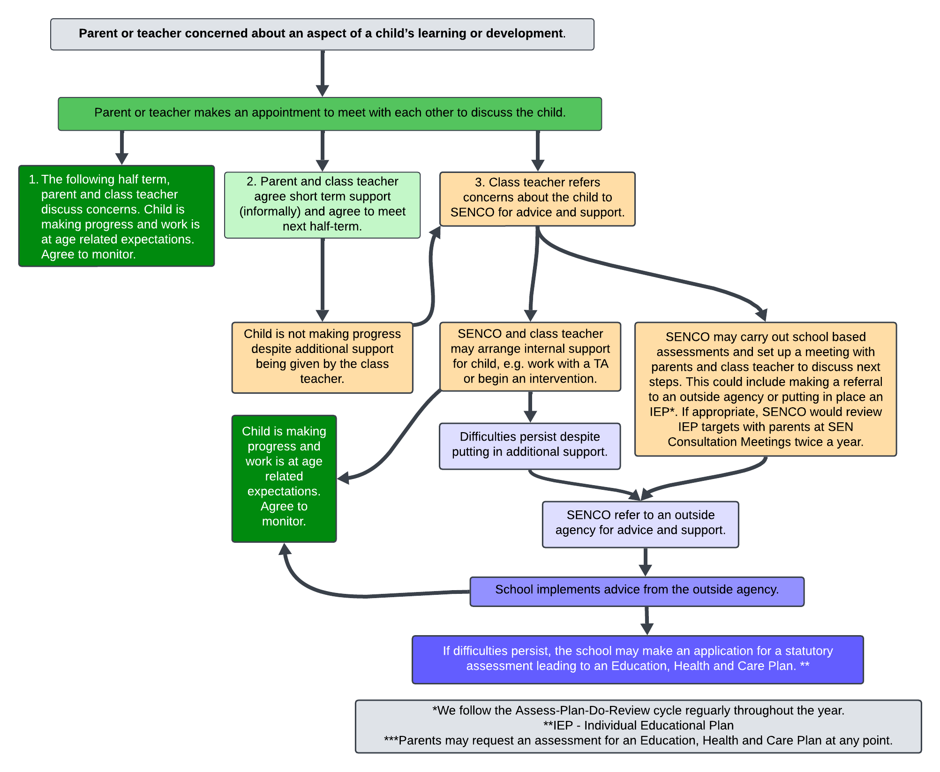

How will Forty Hill CE School support my child’s Special Educational Needs?
The class teacher is responsible for all children in their class, and they provide high-quality teaching, adapted according to need. Tasks are adapted to enable all pupils to succeed, and pupils are challenged to achieve at a high level. Class teachers have regular opportunities for pupil conferencing, with pupils encouraged to reflect on their learning and respond to teachers’ comments.

Pupils are involved in responding to the class teacher’s marking of their work. Marking supports the next steps in learning. The teacher then identifies needs using an ongoing (day-to-day) assessment for learning and coordinates how any additional classroom support is used.

Parents are consulted throughout the different stages of support and will play an essential part in the discussions, planning, decision-making, target setting and possible involvement of external agencies from the first stages of identification and assessment.

Different Types of Support at Forty Hill:
- Quality First Teaching
- The first stage for support will be reasonable adjustment within the classroom through Quality First Teaching strategies which may lead to specific adaptations, scaffolding, more practical learning, adjusting the classroom environment and appropriate resources readily available for SEN in class.
- The class teacher will plan to address the child’s gaps in understanding/learning and use strategies sometimes suggested by the SENDCo to ensure the child is fully involved in learning in class and help them make the best possible progress.

- Specific Group Work/ Interventions
- The child may benefit from an intervention group to target the specific need in the classroom, or another room regularly run by a teacher, a TA or the SENDCo.
- Some children may need targeted support at different times during their schooling, but this does not necessarily mean they have a special educational need or a disability.
- The provision, timescale and impact of targeted teaching and interventions are tracked on provision maps for each class, which are monitored half-termly by the SENCO and Senior Leadership Team.

- Specified Individual Support
- Specified individual support is available for children whose learning needs are severe, complex, and lifelong and is usually provided via an Education, Health and Care Plan (EHCP). This means that your child will have been identified as needing a particularly high level of individual or small-group support by multiple professionals at the SEN panel during the EHCP request process.
- This type of support is available for children with specific barriers to learning that cannot be overcome through Quality First Teaching and intervention groups. A child awarded an EHCP will require specified individual support from specialist external professionals such as the Speech and Language Team (SALT), the EPS or experts from specialist schools such as Waverly.
- Children with an EHCP may sometimes have a personalised curriculum and timetable to ensure they can access an appropriate level of learning and can be assessed on objectives such as the pre-key stage standards or need specific platforms such as the autism progression framework.

Each class has a provision map (details of support across the school). This is updated when needed and provides a clear picture of all the additional interventions (special groups and activities) currently being provided. These may include:
- IDL Literacy and Numeracy Support - an online programme to help children with literacy and numeracy skills for low attainers and those with dyslexic indicators.
- Language for Thinking - to develop vocabulary and comprehension.
- Write from the Start - to develop fine motor skills and handwriting.
- Pastoral Support - to support with social and friendship skills, management of emotions, and a place to be for those who find the playground a challenge.
- WordShark - to support children with Dyslexia or dyslexic indicators
- Alternative provision for children unable to access the curriculum for their year group.
- Ongoing and varied targeted teaching throughout the school, to pre-teach, reinforce or boost learning in core areas.

The impact of any support given is reviewed at the termly pupil progress meetings. Teachers ‘Assess- Plan –Do-Review’ graduated approach enables the SENDCo and class teacher to try a range of interventions and strategies to support the child and measure their impact.

Children on the Special Educational Needs register are monitored, and given SEND Support or specialist support funded by the Local Authority. Those given SEND Support will have an Individual Support Plan (IEP). This is reviewed termly with the class teacher, SENCO, and, where appropriate, the parent. Children with an EHCP will have a personalised EHCP Outcomes document created based on their EHCP. It will provide a clear and individual guide to the child’s needs and outline the necessary steps to support them.

What is an Education, Health and Care Plan (EHCP)?
- If the school, parents, and outside agencies feel that the child has a complex and lifelong need, and requires specialist individual support, then a request can be made to the Local Authority Services to carry out a statutory assessment of your child’s needs.
- After the request has been made to the SEN panel and all the relevant information provided, they will decide whether they think the child’s needs seem complex enough to need a statutory assessment. If this is the case, they will ask parents and all professionals involved to write a report outlining the child’s needs. If they do not think the child needs an EHCP, they will recommend that the school continue with the current support.
- After the report, the panel of professionals will decide whether the needs of the child are severe, complex, and lifelong, and if this is the case, they will co-produce an EHCP.
- The EHCP will outline additional funding the school will receive to support your child in making progress and narrowing the gap between themselves and their peers. If the needs are considered complex enough, a discussion will take place between all parties as to whether the school has the specialist expertise and resources to meet the child’s needs.
- The assessment takes approximately 20 weeks from the day Enfield SEN receives an assessment request.
- The school will be asked to provide evidence showing they have demonstrated that they have attempted to meet the child’s needs themselves but genuinely need additional help.
- All the professionals involved with the child, the parents/carers, and the child themselves are part of the application process.
- The effectiveness of the support will be reviewed and updated termly, by Forty Hill School staff.
- Yearly, there will be a formal annual review meeting with the SENCO and if appropriate and necessary this will include external professionals.

Click here for further information.

How will the curriculum be matched to meet my child’s needs?
In every year group, each subject is adapted to enable all children to access the curriculum. Support may include writing frames with sentence starters, pre-teaching subject-specific vocabulary, additional time to complete tasks and alternative methods of recording such as word processing, diagrams, or access to a scribe. Our aim is for each child to achieve their absolute best, regardless of need.
When a child takes the KS2 National Curriculum Assessments, we can apply for additional time, rest breaks, enlarged print or other special arrangements if these are usual adjustments made within the classroom.

How will I know how my child is doing and how will you help me to support my child’s learning?
Children’s progress is continually monitored by their class teacher, and we formally assess the children at three checkpoints in the academic year, following which the Head Teacher, Senior Mental Health Lead and SENDCo hold a pupil progress meeting with the class teacher and support staff if applicable. Here we look at whether any extra support or intervention is needed at this meeting.

A child’s progress is discussed at our Parents’ Consultation Evenings in the Autumn and Spring terms and through the end-of-year reports to parents. Parents can discuss their child’s end-of-year report with the class teacher. Parents can make an additional appointment with the SENDCo if they want an update or have a concern. We will endeavour to stay in close contact with you about your child, their learning needs, and their progress. Sometimes, we find it helpful to employ additional short-term strategies such as a home/school communication book to ensure ongoing communication between home and school.

When a child is still not making expected progress, the school will discuss any concerns with parents and whether any further interventions or referrals to outside professionals are needed. If your child has been identified as having SEN, we will invite you to meet with us and work with you and your child to set and review clear targets, discuss the support that will help achieve them, review progress, and identify the responsibilities of the parent, the pupil, and the school. You will receive your child’s IEP at each review point, and any questions about these need to be directed towards the class teacher. At any time of the year, you can arrange to meet with your child’s teacher or SENCO to review progress against targets set, or if you have other concerns.

If your child has an Education, Health and Care Plan, there is a formal annual review, where progress against their set EHCP outcomes is reviewed and, where appropriate, new targets are agreed. Parents, the child and, where applicable, all involved professionals are invited to attend this meeting.

Throughout the year we organise parent workshops so they can better support their child’s learning, covering various topics such as phonics and reading, writing, maths, and emotional regulation. In addition, if your child is following a specific programme, we will discuss with you how best you can provide support at home. We can also suggest links to websites that may help your child. If you need more advice, always speak to your child’s teacher.

In June each year, the Year 1 children have the National Phonics Screening assessment. In Year 4, the children take a multiplication check assessment. At the end of Key Stage 2, (Y6), all children are required to be formally assessed using Standard Assessment Tests, (SATs). The results of these tests are published nationally. If a school or the parents feel their child, who has been identified as having a need, should not participate in these assessments, this will be discussed at a meeting before them sitting these assessments. It will be a discussion where all parties will mutually decide what is in the best interest of the child.

What support will there be to support my child’s overall health and well-being?
If a child has a specific medical condition or allergy, you should let the school know before they start with us. It is the parent’s responsibility to provide the school with any medical information and their medication. We have an appointed staff member to administer medicines and support parents in drawing up care plans for their child’s medical needs in school.

Pupils with medical needs will be provided with a detailed individual Health and Care Plan, compiled in partnership with the school nurse, parents and Welfare Officer. Staff who administer and supervise medications will complete formal training. With parental permission, information is shared with relevant staff. Care plans are reviewed and updated at least annually. All medicine administration procedures adhere to the LA policy and Department of Education (DfE) guidelines included within Supporting Pupils at School with Medical Conditions (DfE 2014).

The school offers a wide range of pastoral support for pupils. This includes:
- An evaluated Personal, Social, Health and Economic (PSHE) curriculum that aims to provide pupils with knowledge, understanding and skills they need to enhance their emotional and social knowledge and well-being.
- Learning opportunities and experiences to support the SMSC (Social, Moral, Spiritual, Cultural) curriculum for every child throughout the school year.
- Talk Time with Pastoral Lead/Mentors to provide regular talk time for vulnerable children.
- Regular opportunities to learn outside and take part in our Forest School programme.
- Use of Leuven Scales three times a year to identify children with low well-being and low engagement.
- Pupil and parent voice mechanisms are in place such as the School Council and our annual Vision Parliament, and these are monitored for effectiveness by the Senior Leadership team and the Governor responsible for this area.
- The Drawing and Talking Programme is led by Mrs Izard, the school’s Senior Mental Health Lead and Mrs Watson our Pastoral Lead.

These are identified on the school provision maps and aim to support interaction skills, emotional resilience, and self-awareness.

What specialist support services or expertise are accessed by the school?
This means a pupil has been identified by the SENDCo and class teacher as having a barrier to learning, and they have requested extra specialist advice from a professional outside the school. This may be from Local Authority Central Services:
- Child Development Clinic (CDC)
- Children and Adolescent Mental Health Service (CAMHS)
- Educational Psychology Service (EPS)
- Enfield Advisory Service for Autism (EASA)
- Occupational Therapy (OT)
- Speech and Language Therapist (SALT)
- Strengthening Wellbeing, Emotional Health, Relationships and Readiness for Learning (SWERRL)
- Visual/ Hearing Impairment Services

They will assess your child to understand their needs and make recommendations as to ways in which your child can be supported.

What training have staff supporting children with SEND had or are receiving?
Awareness training has been provided to teaching staff on:
- The Inclusive Classroom
- Writing and implementing an IEP
- Supporting Children with Behavioural Difficulties
- Vulnerability of SEND children in Safeguarding Training
- Main features of Autism and Attachment Disorder (Support Staff with the SENDCo)
- Developmental Language Disorder (DLD). Refresher completed 11.12.24.
Enhanced training has been provided to:
- Understanding and Supporting Children with ASD
- Leading a LASS Group
- Use of Colourful Semantics to Support SLCN and ASD
Specialist Training has been provided to the SENDCo on:
- The SEN Coordination Award (NPQSENCo)
- Regular visits from the Speech Language Therapist, SWERRL Team and Educational Psychologist provide advice and plan structured support for targeted pupils and specific needs.
Specialist Training has been provided to the Headteacher on:
- The SEND Coordination Award (NASENCo)
- The Dyslexic Classroom
- Use of IDL Literacy Support as an intervention and assessment tool
- Use of the Boxhall Profile in assessing the impact of Nurture Groups on individual pupils
- Use of the PODD Book as a form of communication with pupils with PMLD
- Mental Health First Aid.

How will my child be included in activities outside of the classroom?
Educational trips are planned to include all children as far as possible, but we may ask parents of SEND pupils to accompany their child on certain trips to ensure their safety and that of others. This will be a conversation between the parents and the school.
Accurate risk assessments are written to ensure that all eventualities are planned for. We encourage our staff to be risk aware, not risk averse when planning trips.
We welcome suggestions from parents regarding potential visits to places of interest.
We aim to make all reasonable adjustments to ensure that children are included in activities that take place at Forty Hill C.E. School outside of the school day, such as extra-curricular after-school clubs, breakfast and after-school wraparound care.
How accessible is the school environment?
Due to being a grade two listed building, there are limitations to the changes we can make to our structure. We have narrow corridors, small classrooms, and no permanent additional areas dedicated to SEN. Due to the limited space in our school building, we do not have a permanent nurture (withdrawal) room and have a few additional individual learning spaces. We are unable to extend or change the structure of our school site as we are in a conservation area. The Victorian section of the building has steps leading into the playground and a long gravel path to the office and playground. However, we have managed to make small adaptations such as a slope on the left-hand side of our school for access to the building. We have a disabled toilet but no shower facilities.

We will endeavour to make space available in our car park for any person with a valid disabled badge. There is no parking for parents on site, but there is parking at Forty Hall and Jesus Church, both a short distance away up the hill.

How will the school support my child in starting school and moving on?
The Early Years staff will hold a new parent meeting one evening in the Summer Term. Other key members of staff are also present. A home visit is arranged before starting in September for Nursery and new to school Reception children. The SENDCo may attend the home visit if it is felt to be advisable. In the Summer Term, the children and parents of the new intake are invited to the three workshops we provide. These are usually in the afternoon and are a good way for the children and parents to familiarise themselves with the building, the facilities, and the staff in addition to what the workshop provides. This is also an opportunity for parents to meet each other.

Our Nursery Team will work with the parents to develop a positive transition for their children. This may mean they attend an hour-long stay-and-play session with or without their parents or have a staggered start. Currently, we have the option of an open morning for children entering the Nursery and for parents to meet with the Nursery Team. There is a phased system of starting school, with the youngest children starting first. By mid-September, all Reception children generally stay all day.

The Early Years Team are in contact with preschool providers, including SEND services like the Child Development Team (CDT), and Early Speech and Language services to facilitate the smooth transfer to our school.

Concerning admissions during the year, the children are invited to spend some time with their new classmates and are shown around the school by them. If needed, new children can have a staggered start if this is in their best interests. The school will work with the parents to ensure the transition is smooth.

We aim to ensure that there is a smooth transition at the start of the academic year from one class to another within the school. The children visit their new class and have a meet-the-teacher session at the end of the Summer Term. Before this session, teachers will have a handover session where they pass on any information that will aid this transition.

Year 6 pupils are involved in a transition project after KS2 SATs. Because of our location, it is common for our children to move on to a wide range of different secondary providers within and outside the Borough of Enfield. The Year 6 teacher meets with representatives from secondary schools to ensure smooth transfer. Normally, these secondary representatives then meet with the children. Our SENDCo liaises with SENDCos from secondary schools to pass on relevant information.

Children with SEND may need more support with the transition to Secondary school. Where appropriate, our teaching assistants can take the child for additional mornings to see their school in action if parents feel this to be a good idea. They often take a camera, so that the child can take pictures of what they have seen to make a report to which they can refer over the summer if they start to feel anxious.

How are the school’s resources allocated and matched to pupils’ SEN?
The school receives funding to support SEND. This comes from:
- The Notional SEND budget is delegated to schools to support them in meeting the needs of SEND pupils.
- For those with the most complex needs, the school may be allocated additional educational needs funding from the Local Authority which is specified in their EHCP.

This funding is used to buy equipment, provide facilities, and specialist planning to support pupils with special educational needs and disabilities. This might include:
- A contribution to the cost of employing a team of Teaching Assistants, some of whom are trained to deliver 1:1 or small group programmes of support. Teaching Assistants are employed to support the children and the teacher in a variety of ways, one of which is to enable the class teacher to work with small groups.
- Targeted differentiation to increase access to texts and information
- Small group tuition to enable catch-up
- Specific support, advice and guidance for parents and families to improve pupil’s readiness for learning
- Provision of specialist resources or equipment including ICT. Resources are purchased to support children’s access to the curriculum including training and purchase of specific interventions such as WordShark. Curriculum coordinators also have the responsibility for purchasing relevant equipment to support differentiation.
- Partnership working with other settings (shared resources, expertise, alternative environments)
- Access to the school nurse and wider health professionals such as the EP service and EASA
- Implementation of strategies from support agencies e.g., SWERRL.

How will I be involved in discussions about the planning for my child’s education?
Parents/carers are encouraged to be involved in all aspects of school. The school also expects parents to support their children with regular reading and homework. The school organises several parent workshops during the year. Each workshop aims to provide opportunities for parents to learn more about supporting their child’s learning. Parents/carers are invited to class assemblies, curriculum meetings, parental consultation evenings and a meet-the-teacher event at the start of the year. We encourage parents to share their understanding of their child’s needs with the class teacher. Regular communication with parents/carers is through our monthly newsletter, half-termly curriculum booklets and the school website. Emails are sent to remind parents/carers of key events.

The Senior Leadership Team are in the playground before school each day to note any medical or attendance issues, urgent messages for the class teacher, co-ordinating parents’ meeting times and deal with general parental queries. We can access the borough’s translation service. Parents from the school/Church community are often able to support parents where English is not their first language.

The SENDCo is available to meet with parents to discuss their child’s progress and/or any concerns/worries they may have. All information from outside professionals will be discussed with the family of children with SEND. The SENDCo will readily provide information regarding SEND Parent Support Groups in the local area to develop the support network around the family.

Parents/carers are invited to support the school through involvement with the Friends of Forty Hill (Parent and Community association) and the Governing Body. Apart from fundraising, the Friends of Forty Hill also arrange social activities for the children and their families

Who can parents contact for further information?
The first point of contact for anything relating to your child’s education is the class teacher. Appointments can be made either directly or by phoning the school office on 020 8363 0760 or email on office@fortyhill.enfield.sch.uk.
The class teacher will then speak with Mr Pennock who is our SENCO. If you need further support then your next point of contact is Mr Pennock who will be happy to discuss your enquiries or concerns. Mr Pennock can be contacted by emailing or calling the school office.

Our current SEND Governor, Fiona Crack, can be found on the school website and can be contacted via the school office.
Other staff within the school who may work with parents and children of SEN are:

Mr Pennock: Deputy Headteacher, SENCo & DSL

Mrs Watson: HLTA, Pastoral Lead & DSL

Ms Darby: Specialist Teaching Assistant & Pastoral Support

Mrs Vial: Admin and Welfare Officer

Schools work closely with Enfield’s SEN Service and regularly attend training and conferences to ensure consistency and to share information and best practices. The local SEND offer is published on Enfield Council’s website:

https://new.enfield.gov.uk/services/children-and-education/local-offer/

Who can I complain to if I am not happy with the provision in place for my child?
Complaints from parents/carers about the SEND provision in place should be raised with the class teacher in the first instance. Then this should be escalated to the SENDCo who will try to assess and resolve the situation. Formal complaints will be dealt with by the Head Teacher through the school's complaints procedure. The Complaints Policy can be found on the school website.

Glossary of Terms
CAMHS | Child and Adolescent Mental Health Services
CDT | Child Development Team
CPD | Continuing Professional Development
EHCP | Education, Health, and Care Plan
EPS | Educational Psychology Service
IEP | Individual Education Plan
OFSTED | Office for Standards in Education
PSA | Parent Support Advisor
PSHE | Personal, Social and Health Education
SEN | Special Educational Needs
SENCO | Special Educational Needs Coordinator
SEND | Special Educational Needs and Disability
SIAMS | Statutory Inspection of Anglican and Methodist Schools
S&L | Speech and Language
SWERRL | Strengthening Wellbeing, Emotional health, Relationships and Readiness for Learning
TAC/F | Team Around the Child/Family

This ‘Special Educational Needs and Disabilities Information Report’ was produced in October 2025 by Mr Pennock (SENDCo). This Special Educational Needs and Disabilities Information Report will be updated throughout the school year, as relevant, and will be reviewed in October 2026.

