
Forty Hill C.E. School
Science Policy

INTENT
Our Vision
“Jesus said, ‘As I have loved you, so you must love one another. By this everyone will know that you are my disciples.’” John 13:34–35. Following Jesus’s example, we treat each other, our community, and God’s amazing world with love, respect, and compassion. We aspire to ignite curious minds, nurture a passion for learning, and enable everyone to experience and share faith, hope and service.

Our Values
Confidence, Respect, Compassion, Reflective, Responsibility, Resilience.

At Forty Hill, we recognise that science plays a vital role in everyday life. As a core subject within our curriculum, we ensure that the teaching and learning of science are given the prominence and high status they deserve. Science helps children to understand the incredible world God has created. Through active investigation and exploration, children gain knowledge, develop curiosity, and learn to think critically. Science at Forty Hill encourages pupils to ask thoughtful questions, make connections, explore possibilities, and recognise their role as stewards of God’s Earth.

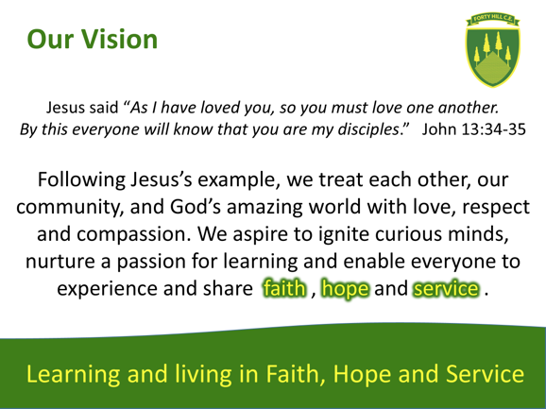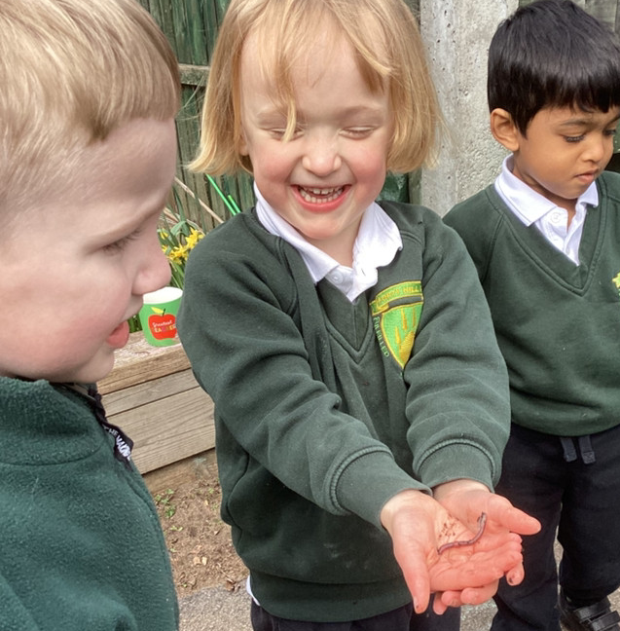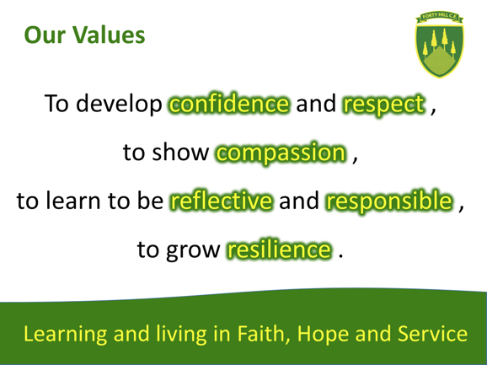

Aims
Our Science curriculum is shaped by the National Curriculum, our school curriculum, alongside our school’s vision and values. We teach science to develop the child as a scientist and to equip them with the scientific knowledge required to understand the uses and implications of science, today and for the future. This means ensuring that the children develop both their knowledge and their skills in the following ways:

1. Promote awe and wonder about the natural world and God’s creation.
2. Ensure full coverage of the National Curriculum for Science.
3. To develop scientific knowledge and conceptual understanding through the specific disciplines of biology, chemistry, and physics
4. To develop understanding of the nature, processes, and methods of science through the development of different types of strong scientific enquiry skills through questioning, experimenting, observing, and evaluating that help them to answer scientific questions about the world around them.
5. Teach key scientific vocabulary confidently and accurately.
6. Provide meaningful, practical, hands-on learning experiences.
7. Encourage resilience, reflection, responsibility, and curiosity in scientific thinking.
8. Help pupils understand environmental sustainability and their responsibility as global neighbours.
9. Ensure that Science learning is accessible, inclusive, and challenging for all learners.

Inclusion and Equal Opportunities
Every child is encouraged and supported to succeed in Science. We aim to provide suitable learning opportunities regardless of gender, ethnicity, or ability/disability. Teachers adapt support and challenge through effective planning to ensure that all learners, including those with SEND and those who are working at greater depth, can achieve and flourish. Teachers should take specific action to enable the effective participation of all pupils. Potential areas of difficulty should be identified and addressed at this stage.

Spirituality and Science
Developing spirituality through primary science in a Church of England school is about helping children experience awe, wonder, curiosity, and meaning as they explore the natural world — recognising that science can deepen appreciation of God’s creation and our place within it.
Spiritual development in science is not about teaching religion — it’s about helping children connect emotionally and reflectively with what they discover.

IMPLEMENTATION
At Forty Hill, our teachers nurture curiosity and enthusiasm for science, ensuring that every child is supported to reach their full potential. Science learning is carefully designed to be progressive, developing knowledge and skills step by step across the key stages. While we previously followed the SNAP Science programme, we now plan our lessons with guidance from PLAN and Primary STEM Education Consultancy, allowing us to tailor our approach to best meet the needs of our learners.
Our science curriculum is carefully mapped out, with a clear overview of topics (both knowledge and skills), when they are taught, and the year groups involved. Cross-curricular links are thoughtfully identified to enrich learning and show the connections between science and the wider world, reflecting our commitment to developing well-rounded, inquisitive learners.

- Science is taught weekly as a discrete subject and enriched through cross-curricular links where appropriate. An afternoon is dedicated to the subject in both Key Stages 1 and 2. This ensures that children have sufficient time to develop both their scientific knowledge and practical skills, while also addressing any misconceptions that may arise during lessons.
- Lessons are planned using the school’s Science Progression documents to ensure continuity and high expectations.
- We place a strong emphasis on working scientifically, encouraging children to ask questions, investigate, and apply their learning to solve problems. Lessons provide opportunities for children to use scientific skills and, in Key Stage 2, carry out research to discover answers independently.
- Teachers support pupils in developing reasoning, confidence, and independence in scientific enquiry.
- Outdoor learning, our school grounds and local area are actively used to enrich Science experiences.
- Classrooms feature a science working wall, displaying rich topic vocabulary, diagrams, and images linked to the unit being taught that half term.
- Scientific vocabulary is explicitly taught and revisited to strengthen understanding and communication.
- At the start of each half term, children are assessed on their previous knowledge of the unit. This helps teachers know where the children’s starting point is and informs teachers’ planning and assessment of attainment and progress.
- Trips, visitors, workshops, and Science Week further enrich learning, promote aspiration, and inspire curiosity.

Assessment
At Forty Hill, assessment is an integral part of science teaching and is ongoing throughout the learning process. Teachers evaluate children’s progress using a range of methods, including pre- and post-assessments, observing them at work, questioning, class discussions, quizzes, marking, written and verbal feedback, practical sessions, and independent learning in books.

To formally assess pupils’ progress, we use National Curriculum objectives to evaluate achievements as emerging, expected, or exceeding for both subject knowledge and skills. In the Early Years Foundation Stage, teachers primarily use the Understanding the World area as guidance, while also considering other relevant areas.

Assessment information is shared with the Headteacher and the Science Lead to monitor progress and attainment, and to inform reports to Governors. Annual reports to parents also indicate each child’s progress and achievements in science, ensuring families are fully informed of their child’s development in this subject.

Role of the Science Subject Leader
The Science Subject Leader will:
- Monitor planning, teaching, and attainment in Science.
- Support staff confidence, skills, and resources for outstanding Science teaching.
- Lead curriculum development and promote high-quality enquiry-based learning.
- Coordinate enrichment opportunities, including Science Week and workshops.
- Ensure resources are maintained and replenished.
- Report to SLT and Governors on standards and progress.

Approaches in Science:
- Start with Wonder
  - Begin lessons with an engaging question or phenomenon that sparks awe: “Why does a rainbow appear?” “How do birds know where to migrate?”
  - Give space for children to express amazement before jumping into explanation.
- Encourage Reflective Pause
  - After practical investigations, ask questions like:
    - “What did you find most amazing about what we discovered?”
    - “How does this make you think about the world differently?”
  - Use quiet reflection moments or “awe journals.”
- Connect to Care and Responsibility
  - Link science to ethical and environmental reflection: “How should we look after God’s world?”
  - Projects on recycling, pollution, or biodiversity can include reflection and prayer.
- Celebrate Mystery
  - Acknowledge that science doesn’t answer everything — some things remain mysterious.
  - This can nurture humility, curiosity, and openness to deeper wonder.
- Cross-curricular Links
  - Link with RE, PSHE, or collective worship.
  - Use scripture, art, or poetry alongside science to deepen reflection (e.g., creation psalms, songs of praise for nature).

Links to Our Christian Ethos
Science education at Forty Hill strengthens pupils’ understanding of themselves, others, and the world. It supports them in:
- Recognising the beauty, complexity and wonder of God’s creation.
- Understanding their role as responsible and compassionate global citizens.
- Developing reflective and thoughtful responses to ethical and environmental issues.
- Living out our shared values of confidence, respect, compassion, responsibility, and resilience.

IMPACT (How will this be measured?)

Pupil voice will show:
- A clear progression of learning and understanding, supported by accurate and age-appropriate scientific vocabulary.
- An increasing understanding of how scientists work, including the methods and enquiry skills used to investigate the world.
- Growing confidence in applying key scientific concepts and making links across learning.
- Confidence when talking about Science, their investigations, and their own achievements.

Working walls around the school and pupils’ books will show:
- A rich, engaging Science curriculum that develops a wide range of scientific skills.
- Evidence that pupils have regular opportunities to practise, apply and refine their enquiry skills.
- Clear progression in skills, knowledge, and vocabulary across year groups.
- That pupils develop secure, well-rounded scientific abilities across all areas of the Science curriculum.

The Science Subject Leader will:
- Monitor standards in Science to ensure outcomes meet or exceed expected levels.
- Provide ongoing CPD and support based on monitoring findings so that the impact of the Science curriculum is strong and consistent across the school.
- Review and update Science documentation regularly to ensure clarity, consistency and continued alignment with school vision and statutory requirements.

Health and Safety
Teachers ensure that all investigations and practical work follow national and school health and safety guidelines, with risk assessed when necessary.

Monitoring and Review
To monitor and evaluate science, the subject leader will:
- Provides strategic leadership by supporting colleagues in teaching, learning, and professional development.
- Conducts work and planning reviews, lesson observations, learning walks, and pupil interviews, identifying strengths and areas for improvement.
- Ensures the school stays up to date with national and local expectations.
- Reviews resources and shares best practices in science with staff.

This policy is reviewed regularly by the Science leader and ratified every two years by the Governing Body.

Accepted by the Governing Body: November 2025
Review Date: November 2027

