Early Years Foundation Stage (EYFS) Policy



Forty Hill CE Primary School Vision for Education:

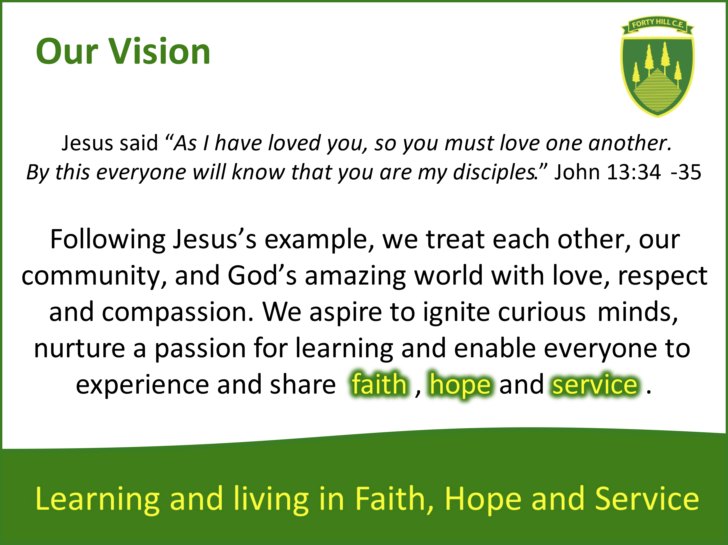

INTRODUCTION

Our school’s vision is rooted in the words and actions of Jesus which demonstrate the virtues of faith, hope and service. We implement the Early Years Foundation Stage (EYFS) Framework alongside this faith foundation and ensure that every child’s early educational experience is rich and meaningful. Every child is unique and as soon as they begin their EYFS journey are encouraged to share how this is so as we transition with an All About Me focus. They develop this understanding alongside a new sense of belonging to their Class and the wider School Community. The Christian ethos of the school means that the children’s day begins and ends with prayer. The EYFS framework supports understanding the ways in which people are similar and different physically and because of the things they believe in and celebrate. At Forty Hill this diversity is explored more fully in explicit Religious Education teaching sessions and a provision that promotes being curious. Our interactive environments allow children to follow and explore their curiosity first hand and support an understanding of hope in a both a biblical and personal sense. Hope in God’s promises to, and love for, us and a sense of responsibility about the impact of our behaviours and actions upon each other and the world around us. Jesus’s example of love at the last supper supports learning to think about the perspective of others and demonstrates love in action through service. Our holistic approach means learning and living in Faith, Hope and Service is something that is both demonstrated and experienced with the aim of developing life affirming learners with a life-long love of learning.

The EYFS applies to children from birth to five (the end of the Reception year) and is intended to ensure that children learn and develop well and are kept healthy and safe. Early childhood is the foundation on which children build the rest of their lives, it is not solely preparation for ‘school readiness’ but is vitally important in itself. Our setting fosters an environment that enables children to develop a broad range of knowledge and skills that they will continue to hone throughout their life.

We know that “Children learn and develop at a faster rate from birth to five years old than at any other time in their lives, so their experiences in early years have a major impact on their future life chances. A secure, safe, and happy childhood is important in its own right”.

(Early years foundation stage (EYFS) statutory framework, Published 31 March 2014 and Last updated 1 November 2024)

Our EYFS accommodates children in the Nursery (3-4yrs) and Reception (4-5yrs) and each class has a full time teacher and a full-time teaching assistant/s. To ensure best practice, and continuity, our classes work closely together, share planning, activities and are blessed with wonderful outdoor learning environments and opportunities. We are strong advocates of child-initiated learning and ensure that any directed tasks are equally rewarding and enjoyable experiences. It is never ‘just play’ because these opportunities allow children to explore, investigate discover, create, practice, rehearse, repeat, revise and consolidate their developing knowledge, skills, understanding and attitudes. Playing together is learning together, and we aspire to kindle a love of learning that remains lifelong. Our commitment to providing high quality and inclusive education is something we pride ourselves on. In this way we recognise that each child is unique, will learn and make progress differently, and will be able to fulfil their potential and experience success.

LEGISLATION
This policy is based on requirements set out in the statutory framework for the Early Years Foundation Stage (EYFS) that applies from 1 November 2024

We adhere to the ‘Statutory Framework of the EYFS’ and the four guiding principles that shape practice within Early Years settings:
- Quality and consistency in all early years settings, so that every child makes good progress, and no child gets left behind.
- A secure foundation through planning for the learning and development of each individual child, and assessing and reviewing what they have learned regularly.
- Partnership working between practitioners and with parents and/or carers.
- Equality of opportunity and anti-discriminatory practice, ensuring that every child is included and supported.

Four guiding principles should shape practice in early years. These are:
• Every child is a unique child, who is constantly learning and can be resilient, capable, confident, and self-assured.
• Children learn to be strong and independent through positive relationships.
• Children learn and develop well in enabling environments with teaching and support from adults, who respond to their individual interests and needs and help them to build their learning over time. Children benefit from a strong partnership between practitioners and parents and/or carers.
• Importance of learning and development. Children develop and learn at different rates. (See “the characteristics of effective teaching and learning” at paragraph 1.18). The framework covers the education and care of all children, including children with special educational needs and disabilities (SEND)

Statutory framework for the early years foundation stage for group and school providers (publishing.service.gov.uk)

We also refer to the Non-Statutory curriculum guidance for the EYFS Development Matters - September 2020.

EYFS AIMS

We are ambitious and enthusiastic in the planning and implementation of our curriculum, which we base around high quality texts, and ensure that every child has full access to our provision. We recognise the place for directed learning tasks but consider child-initiated play to be a rich learning experience, each encompassed by high quality interactions and questioning to develop children’s thinking. The children are supported to develop problem-solving skills through open-ended tasks, opportunities to share their thinking with others and develop a strong sense of self. Being able to communicate our needs and thoughts is essential in life and it is a priority to model high standards of oracy to develop early articulacy. Planned and ‘in the moment’ observations provide authentic opportunities to assess and monitor children’s needs, interests, and stages of development across the seven areas of learning which ultimately enable children to achieve the Early Learning Goals assessed at the end of Reception.

“When we succeed in giving every child the best start in their early years, we give them what they need today. We also set them up with every chance of success tomorrow.”

(Development Matters Non-statutory curriculum guidance for the Early Years Foundation Stage September 2020)

Teaching and Learning

There are seven areas of learning and development that are important and interconnected.
Three areas are particularly crucial for igniting children's curiosity and enthusiasm for learning, and for building their capacity to learn, form relationships and thrive, both in the EYFS and into Key Stage 1.
These three areas are the prime areas:
• Communication and Language
• Physical Development
• Personal, Social and Emotional Development

Children are also supported through the four specific areas, through which the three prime areas are strengthened and applied:
• Literacy
• Mathematics
• Understanding the World
• Expressive Arts and Design

In planning and guiding children’s activities, practitioners must reflect on the different ways that children learn and reflect these in their practice. Three characteristics of effective teaching and learning are:
1. Playing and exploring - children investigate and experience things, and ‘have a go’.
2. Active learning - children concentrate and keep on trying if they encounter difficulties.
3. Creating and thinking critically - children have and develop their own ideas, make links between ideas and develop strategies for doing things.

Planning

We plan activities and experiences linked to texts and topics which offer experiences in all seven learning areas. These plans then inform our weekly planning, alongside our observations, which remain flexible to accommodate ‘unplanned’ opportunities which arise due to child responses and wider enrichment opportunities.

Practitioners working with the youngest children in Nursery will focus strongly on the three prime areas, which are the basis for successful learning in the other four specific areas. The three prime areas reflect the key skills all children need to develop and learn effectively. In Reception this changes as children incorporate longer Phonics sessions, which include reading and the opportunity to practise and apply their skills to spell words. In Reception children will progress to reading in small groups and complete directed Literacy and Maths tasks. Reception also follow the London Diocesan Board for Schools (LDBS) plans for Religious Education which is taught weekly. Yearly overviews are communicated on our school website as well as half termly Curriculum Booklets which provide more detailed information about your child’s learning and ways you can support them at home.

Assessment

At Forty Hill, ongoing assessment is an integral part of the learning and development processes, and every member of the team contributes to capturing achievements, interests and learning styles. These observations are used to shape future planning and to enable us to support children where they need it most in order for them to flourish. Children’s learning experiences are collated and shared with parents via the Tapestry platform. Parents/carers receive a notification when an observation has been added to their child’s Learning Journal, and they can then view this observation and any related photographs/videos and assessments. Parents/carers are encouraged to add their own comments and also to upload their own observations to show us what their children are able to do at home.

The Statutory Reception Baseline Assessment (RBA, May 2021) must be administered in the first six weeks that a child starts Reception. The RBA is a short, interactive and practical assessment of your child’s early literacy, communication, language and mathematics skills when they begin school, using materials that most children of your child’s age will be familiar with. It is not a ‘pass’ or ‘fail’ assessment and as a result the outcomes are not shared. Its main purpose is to create a starting point to measure the progress schools make with their pupils. At the end of the EYFS, staff complete the EYFS profile for each child. The ELGs are: Listening, Attention and Understanding, Speaking, Self-regulation, Managing Self, Building Relationships, Gross Motor Skills, Fine Motor Skills, Comprehension, Word Reading, Writing, Number, Numerical Patterns, Past and Present, People Culture and Communities, The Natural World, Creating with Materials and Being Imaginative and Expressive.
Pupils are assessed against the 17 early learning goals, indicating whether they are:
- Meeting expected levels of development
- Not yet reaching expected levels (‘emerging’)

The profile reflects ongoing observations, and discussions with parents and/or carers. The results of the profile are shared with parents and/or carers for their child. The profile is moderated internally (referring to the Development Matters guidance) and in partnership with other local schools, to ensure consistent assessment judgements. EYFS profile data is submitted to the local authority.

THE ROLE OF PARENTS/CARERS

A secure, safe, and happy childhood is important in its own right. Good parenting and high-quality early learning provide the foundation children need to fulfil their potential.

(Early years foundation stage (EYFS) statutory framework, Published 31 March 2014and Last updated 1 November 2024)

We recognise the central importance of parents/carers as children’s first educators. We believe they have a significant role to play in the lifelong education of their child. We strive to create and maintain partnerships with parents/carers as we recognise that together, we can have a significant impact on a child’s learning.
We welcome and actively encourage parents to participate confidently in their child’s education and care in numerous ways.
- Holding information evenings before the children start school;
- Talking to them about their child’s interests and needs during our introductory sessions in school and at our home visits .
- Being welcoming and approachable in order that parents can to voice concerns/ask questions;
- Inviting them to a parent consultation in the Autumn and Spring Terms to discuss how their child has settled and share progress and next steps for learning;
- Valuing parents’ contributions to Tapestry learning journeys;
- Encouraging parents to read with their child at home and make comments in their reading record books;
- Providing curriculum planning overviews for each topic, each term pointing them to ways they can support their child at home;
- Inviting parents into school for workshops to demonstrate how we teach phonics and help them support their child;
- Providing parents with an end of year summary report detailing achievements and their child’s EYFS profile

Safeguarding and welfare procedures

The safety and welfare of our children is paramount at Forty Hill Primary School. We have robust policies and procedures in place to ensure their safety. (See whole school Policies)

In Nursery and Reception we provide a safe and secure environment and a curriculum which teaches children how to take risks, follow rules and stay safe. We comply with the welfare requirements set out in the Statutory Framework for Early Years Foundation Stage and understand that we must:
- Safeguard children.
- Ensure the adults who have contact with children are suitable.
- Promote good health.
- Support and understand behaviour.
- Maintain records, policies, and procedures.
We promote the good health of the children in our care in numerous ways, including the provision of nutritious fruit and snacks, access to water and milk throughout the day, allocating significant time for physical development and following set procedures when children become ill or have an accident. (See whole school policies)
One member of staff in each setting holds a Paediatric First aid qualification, which is a statutory requirement of the EYFS.

Role of the Early Years Lead
It is the responsibility of the Early Years Lead
- To guide the Early Years team in the planning and delivery of a creative and stimulating curriculum.
- To ensure the curriculum supports a range of learning styles and develops children's independence.
- To take responsibility for high quality teaching provision throughout the Early Years stage.
- To attend regular training with the LA
- To keep up to date with any changes in policy and implement these effectively
- To continually model and set high standards for all practitioners to follow
- To develop and creatively expand the indoor and outdoor Learning Environment to ensure that the environment provides opportunities for stimulating learning and experiences
- To ensure high quality and effective assessment of pupils across the Early Years and through the completion of the Early Years Foundation Stage profile
- To be a key contributor to the Leadership Team, supporting the ethos and standards of the school and determining its needs and priorities
- To build a collaborative Early Years team, reacting to staff needs through mentoring and mutual support.
- To initiate, embrace and manage change positively in line with the School Improvement Plan.

Review
This policy is a working document and therefore is open to change and restructuring as and when the need arises. It is reviewed regularly by the Headteacher and the school’s Early Years Lead and ratified every two years by the Governing Body.

Accepted by the Governing Body: 13th February 2025

Review Date:

