 | Autumn 1 | Autumn 2 | Spring 1 | Spring 2 | Summer 1 | Summer 2
Nursery key texts | 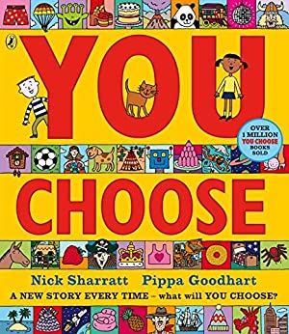  + children’s own favourite stories from home | 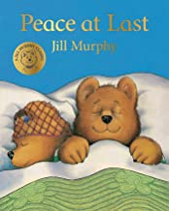  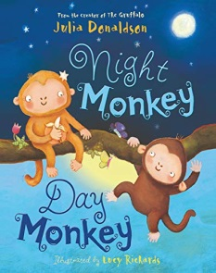 | 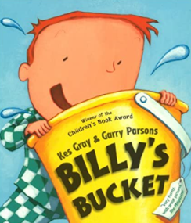  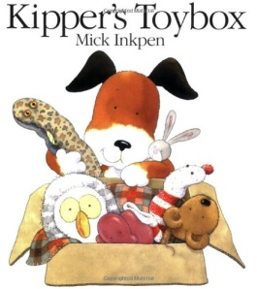 | 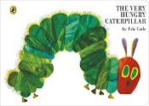  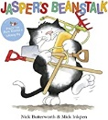 | 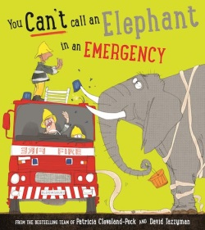  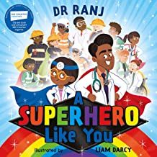 | 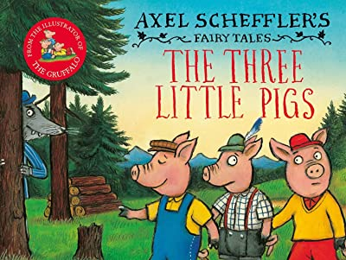  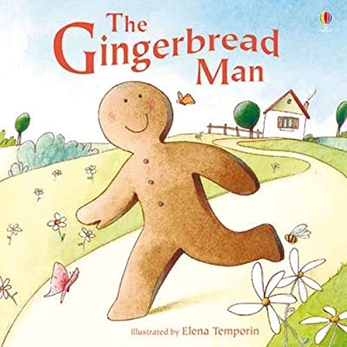
Intended outcomes | - Understand the five key concepts about print:  - • print has meaning  - • we read English text from left to right and from top to bottom | - Understand the five key concepts about print:  • print has meaning  • we read English text from left to right and from top to bottom  • the names of the different parts of a book  - Engage in extended conversations about stories, learning new vocabulary. | - Understand the five key concepts about print:  • print has meaning  • print can have different purposes  • we read English text from left to right and from top to bottom  • the names of the different parts of a book  • page sequencing  - Engage in extended conversations about stories, learning new vocabulary | - Understand the five key concepts about print:  • print has meaning  • print can have different purposes  • we read English text from left to right and from top to bottom • the names of the different parts of a book • page sequencing  - Engage in extended conversations about stories, learning new vocabulary. | - Understand the five key concepts about print:  • print has meaning  • print can have different purposes  • we read English text from left to right and from top to bottom • the names of the different parts of a book • page sequencing  - Engage in extended conversations about stories, learning new vocabulary.  - Use some of their print and letter knowledge in their early writing. For example: writing a pretend shopping list that starts at the top of the page; writing ‘m’ for mummy. Write some or all of their name.  - Write some letters accurately. | - Understand the five key concepts about print:  • print has meaning  • print can have different purposes  • we read English text from left to right and from top to bottom • the names of the different parts of a book • page sequencing  - Engage in extended conversations about stories, learning new vocabulary.  - Use some of their print and letter knowledge in their early writing. For example: writing a pretend shopping list that starts at the top of the page; writing ‘m’ for mummy. Write some or all of their name.  - Write some letters accurately.
Reception key texts | 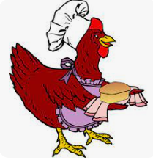  Little Red Hen – Pie Corbett (2010 retelling) | 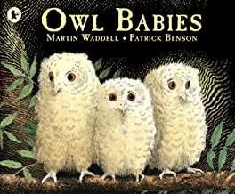  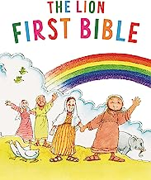  The Nativity Story | 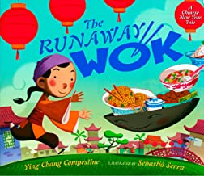  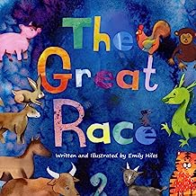 | 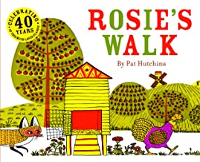  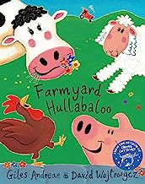 | 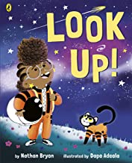  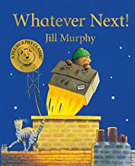 | 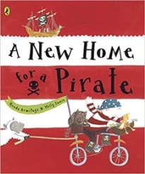  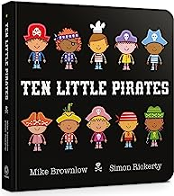
Intended outcomes | Read individual letters by saying the sounds for them.  Read some letter groups that each represent one sound and say sounds for them.  Read a few common exception words matched to the school’s phonic programme.  Read simple phrases and sentences made up of words with known letter–sound correspondences and, where necessary, a few exception words.  Re-read these books to build up their confidence in word reading, their fluency and their understanding and enjoyment.  Form lower-case and capital letters correctly.  Spell words by identifying the sounds and then writing the sound with letter/s.  Write short sentences with words with known sound-letter correspondences using a capital letter and full stop.  Re-read what they have written to check that it makes sense | Read individual letters by saying the sounds for them.  Blend sounds into words, so that they can read short words made up of known letter– sound correspondences.  Read a few common exception words matched to the school’s phonic programme.  Read simple phrases and sentences made up of words with known letter–sound correspondences and, where necessary, a few exception words.  Form lower-case and capital letters correctly.  Spell words by identifying the sounds and then writing the sound with letter/s.  Re-read what they have written to check that it makes sense | Read individual letters by saying the sounds for them.  Read a few common exception words matched to the school’s phonic programme.  Read simple phrases and sentences made up of words with known letter–sound correspondences and, where necessary, a few exception words.  Re-read these books to build up their confidence in word reading, their fluency and their understanding and enjoyment.  Form lower-case and capital letters correctly.  Spell words by identifying the sounds and then writing the sound with letter/s.  Re-read what they have written to check that it makes sense | Read individual letters by saying the sounds for them.  Blend sounds into words, so that they can read short words made up of known letter– sound correspondences.  Read a few common exception words matched to the school’s phonic programme.  Read simple phrases and sentences made up of words with known letter–sound correspondences and, where necessary, a few exception words.  Re-read these books to build up their confidence in word reading, their fluency and their understanding and enjoyment.  Form lower-case and capital letters correctly.  Spell words by identifying the sounds and then writing the sound with letter/s.  Write short sentences with words with known sound-letter correspondences using a capital letter and full stop.  Re-read what they have written to check that it makes sense | Read individual letters by saying the sounds for them.  Blend sounds into words, so that they can read short words made up of known letter– sound correspondences.  Read a few common exception words matched to the school’s phonic programme.  Read simple phrases and sentences made up of words with known letter–sound correspondences and, where necessary, a few exception words.  Re-read these books to build up their confidence in word reading, their fluency and their understanding and enjoyment.  Form lower-case and capital letters correctly.  Spell words by identifying the sounds and then writing the sound with letter/s.  Write short sentences with words with known sound-letter correspondences using a capital letter and full stop.  Re-read what they have written to check that it makes sense | Read individual letters by saying the sounds for them.  Read a few common exception words matched to the school’s phonic programme.  Read simple phrases and sentences made up of words with known letter–sound correspondences and, where necessary, a few exception words.  Blend sounds into words, so that they can read short words made up of known letter– sound correspondences.  Re-read these books to build up their confidence in word reading, their fluency and their understanding and enjoyment.  Form lower-case and capital letters correctly.  Spell words by identifying the sounds and then writing the sound with letter/s.  Write short sentences with words with known sound-letter correspondences using a capital letter and full stop.  Re-read what they have written to check that it makes sense
Year 1 key texts and genres  Writing to entertain  Writing to inform | 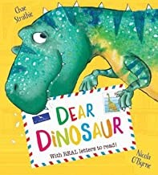  Dear Dinosaur by Chae Strathie  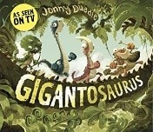  Gigantosaurus by Jonny Duddle | 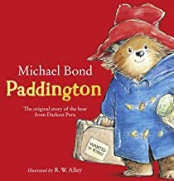  Paddington by Michael Bond  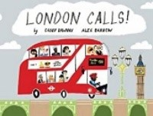  London Calls! by Gabby Dawnay | 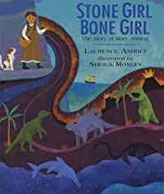  Stone Girl, Bone Girl by Laurence Anholt  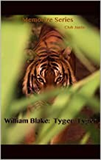  The Tyger by William Blake | 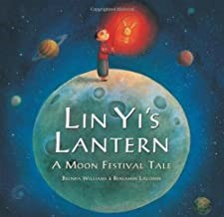  Lin Yi’s Lantern by Brenda Williams  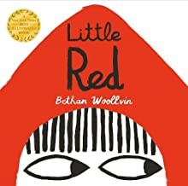  Little Red by Bethan Woolvin | 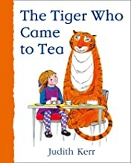  The Tiger Who Come to Tea by Judith Kerr  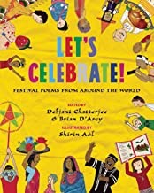  Let’s Celebrate by Debjani Chaterjee and Brian D’Arcy | 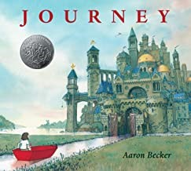  Journey by Aaron Becker
Intended outcomes | Writing to inform  Letter writing  Writing to entertain  Story – character and setting description | Writing to entertain  Character description.  Writing to inform Non-Fiction - writing about London | Writing to entertain  Diary entries  Poetry (write and perform) Kennings | Writing to entertain  Fairy and traditional tales  Narrative – Retelling  Writing to inform  Little Red – Newspaper | Writing to inform  Instruction writing How to make a Jam Sandwich  Writing to entertain  Repetition | Writing to entertain  Narrative for pictureless book  Writing to inform  Recount
Year 2 key texts and genres  Writing to entertain  Writing to inform | 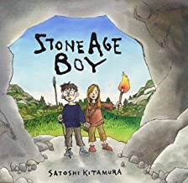  Stone Age Boy – Satoshi Kitamura | 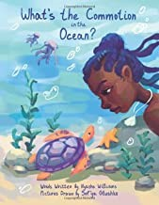  What’s the commotion in the Ocean? – Nyasha Williams  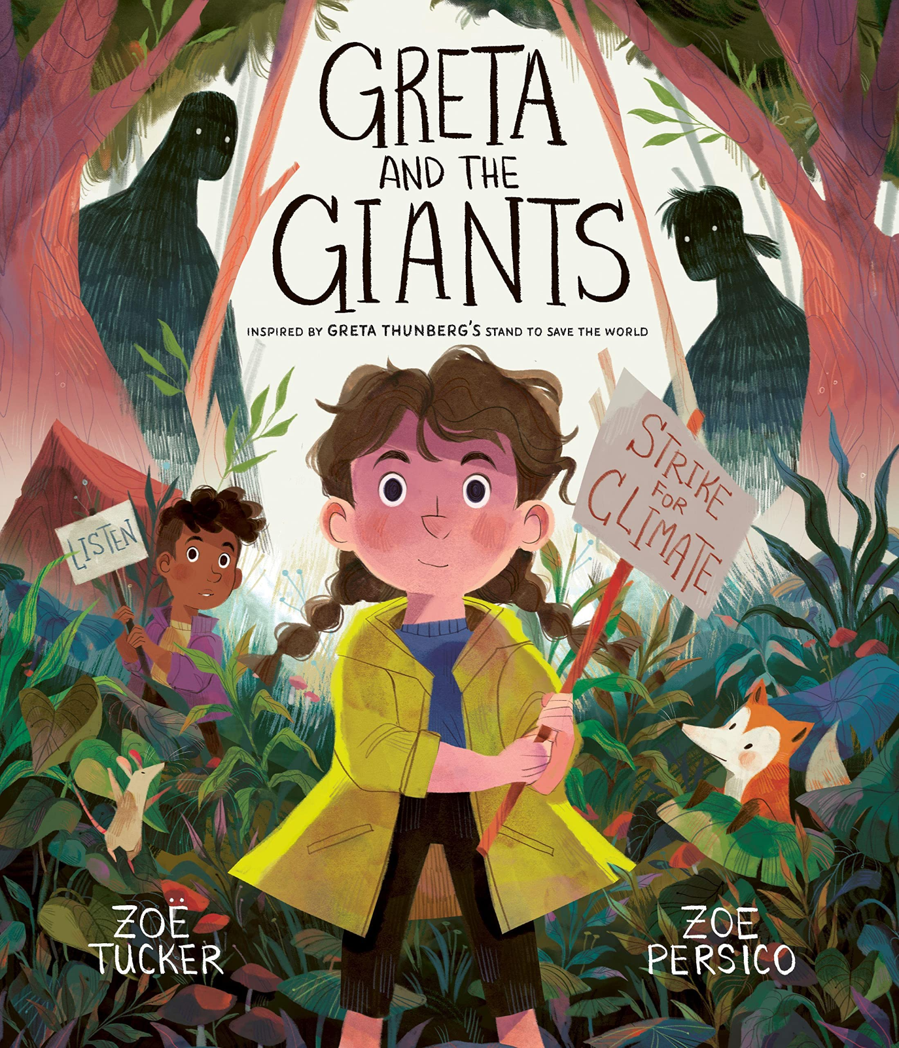  Greta & The Giants - Zoe Tucker | 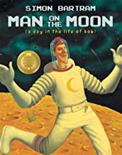  Man on the Moon – Simon Bartrum  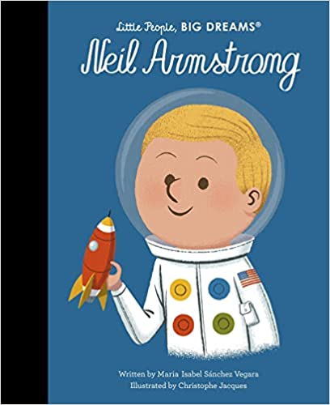  Neil Armstrong – Little People Big Dreams | 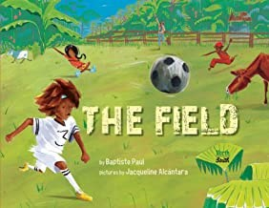  The Field – Baptiste Paul  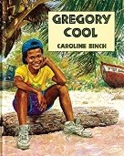  Gregory Cool – Caroline Binch | 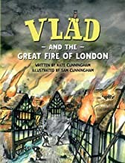  Vlad and the Great Fire of London – Kate & Sam Cunningham | 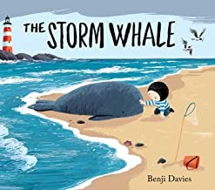  The Storm Whale – Benji Davis  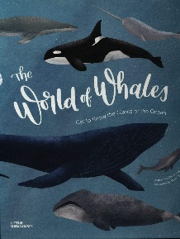  The World of Whales – Little Gestalten
Intended outcomes | Writing to entertain  Setting Descriptions | Writing to entertain  Rhyming poetry  Writing to inform  Non-fiction – Newspaper | Writing to entertain  Narrative Writing with character description  Writing to inform  Biographies | Writing to entertain  Poetry from the Caribbean  Story – setting and character description | Writing to entertain  Diary entries  Writing to inform  Newspaper writing (Through Topic) | Writing to inform  Explanation and persuasive writing – Information Booklet
Year 3 key texts and genres  Writing to entertain  Writing to inform  Writing to persuade | 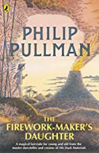 | 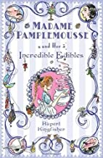 | 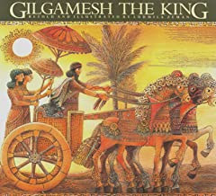 | 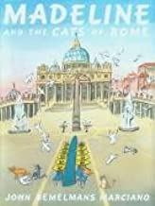  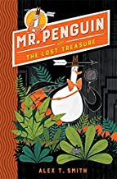 | 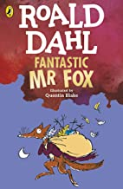 | 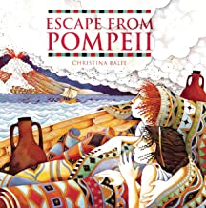
Intended outcomes | Writing to entertain (T4W): Description of a jungle (using setting from book)  Writing to persuade: Letter to character’s father explaining why she should become a Firework Maker  Writing to inform  Multicultural week: Biography – Nelson Mandela | Writing to entertain (T4W): Narrative including dialogue  Writing to inform: Explanation text for how to create an Incredible Edible | Writing to entertain (T4W): Rewriting narrative with an alternative ending – book as model text  Writing to entertain: Haiku poem based on story (Gilgamesh is one of the world’s oldest poems) | Writing to entertain (T4W): Play scripts – using dialogue from the book and creating play scripts from this (Mr Penguin)  Writing to persuade: Persuasive poster for people to adopt the cats of Rome  (Cats of Rome) | Writing to inform (T4W): Newspaper article based on Fox’s raids on the farms.  Writing to inform: 1st person recount of raid from perspective of Mr Fox. | Writing to entertain (T4W): Narrative which describes actions (eruption scene)  Writing to persuade: Persuasive leaflets to encourage tourism to site of Pompeii now.
Year 4 key texts and genres  Writing to entertain  Writing to inform  Writing to persuade | 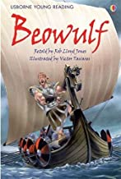  Beowulf – Rob Lloyd Jones | 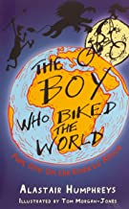  The Boy Who Biked The World – On the Road to Africa – Alistair Humphreys | 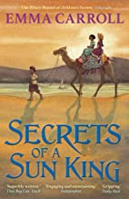  Secrets of a Sun King – Emma Carroll | 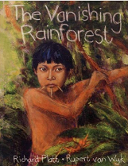  The Vanishing Rainforest – Richard Platt | 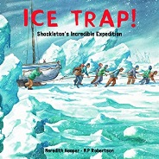  Ice Trap! – Meredith Hooper | 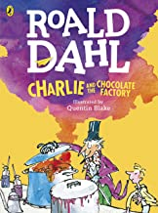  Charlie and the Chocolate Factory – Roald Dahl
Intended outcomes | Writing to entertain – Writing to introduce setting  Writing to entertain – Writing to describe action (TfW) | Writing to inform – Explanation text on how to survive in a desert (Elements of TfW)  Writing to entertain – Recount | Writing to persuade – Persuasive letter to Ms Izard to allow our trip to the British Museum  Writing to entertain – Writing to create suspense (TfW) | Writing to inform – Newspaper (deforestation)  Writing to entertain – Tanka poems  Topic: Writing to inform  Advert Poster | Writing to entertain – Diary/ Letter writing  Topic: Writing to inform – Biography of Ernest Shackleton | Writing to entertain – Narrative including dialogue (TfW)  Writing to entertain – Play scripts
Year 5 key texts and genres  Writing to entertain  Writing to inform  Writing to persuade  Writing to discuss | Autumn 1  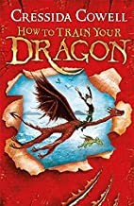  How To Train Your Dragon by Cressida Cowell | Autumn 2  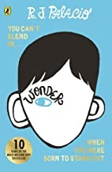  Wonder by R.J. Palacio | Spring 1  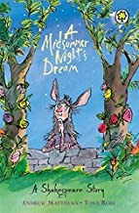  A Midsummer’s Night Dream by William Shakespeare  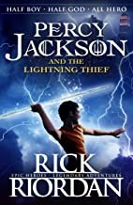  Percy Jackson and The Lightning Thief by Rick Riordan | Spring 2  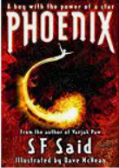  Phoenix by S.F. Said | Summer 1  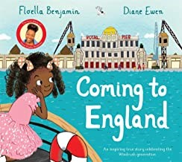  Coming To England by Floella Benjamin | Summer 2  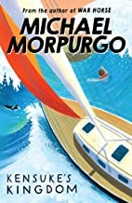  Kensuke’s Kingdom by Michael Morpurgo
Intended outcomes | Writing to entertain  TFW unit: fantasy / adventure  Focus: suspense  Writing to inform  Non-fiction: non-chronological report about dragons or instructions / explanations  Writing to persuade  Multi-cultural week: persuasive speech (Martin Luther King) | Writing to entertain  TFW unit: familiar settings / real life stories  Focus: dialogue  Writing to persuade  Non-fiction: balanced argument about school | Writing to entertain  Shakespeare unit: comedy/fantasy  Focus: playscripts  TFW unit: Myths & Legends  Focus: character description / mythological description  Writing to discuss  Non-fiction: debate (Athens vs Sparta) in Topic | Writing to entertain  TFW unit: science fiction  Focus: action/defeating a monster (alien)  Writing to discuss  Non-fiction: newspaper article about Pluto | Writing to entertain  Fiction: Diary entry  Performance poetry: John Agard (link to Topic)  Writing to inform  Non-fiction: biography of Floella Benjamin | Writing to entertain  TFW unit: journey  Focus: setting description  Writing to persuade  Non-fiction: persuasive advert for the trip around the world
Year 6 key texts and genres  Writing to entertain  Writing to inform  Writing to persuade  Writing to discuss | Autumn 1  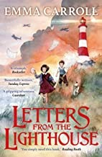  Letters From The Lighthouse by Emma Carroll | Autumn 2  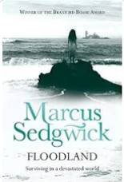  Floodland by Marcus Sedgwick | Spring 1  A Midsummer Night’s Dream by William Shakespeare  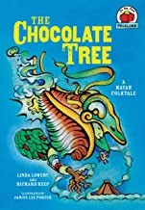  The Chocolate Tree by Linda Lowery | Spring 2  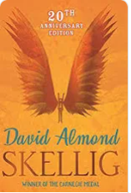  Skellig by David Almond | Summer 1  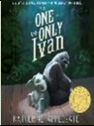  The One and Only Ivan by Katherine Applegate | Summer 2    There’s a Boy in the Girls’ Bathroom by Louis Sachar
Intended outcomes | Writing to entertain  TFW Unit – narrative Focus: setting description  Writing to inform  Poetry – evacuee, The Blitz spine poem  Book Review – Letters from the Lighthouse  Writing to persuade  Speech campaigning for free school meals (Multicultural Week) | Writing to discuss  Balanced argument – main character choices  Writing to entertain  TFW Unit – narrative Focus: characterisation and dialogue  Diary entries and letters in role (link to TFW) | Writing to entertain  Playscripts  Writing to inform  Instructional report – Mayan Ball Game (Topic)  Writing to entertain  Mayan folktales | Writing to entertain  TFW Unit – narrative Focus: creating suspense  Writing to inform  TFW unit – non-fiction Newspaper reports  Writing to discuss  Balanced argument – home schooling | Writing to discuss  Biased argument – animals in captivity  Writing to inform  Biography of Sir David Attenborough  Writing to persuade  Persuasive writing linked to traffic calming (Global Neighbours Week) | Writing to entertain  Letter to main characters  Diary entries

