
Forty Hill CE School Marking Policy
Forty Hill CE Primary School Vision for Education:


Intent
Marking and feedback form an essential part of teaching and learning at Forty Hill School. We believe that both oral and written feedback should be constructive and make clear where children have used their success criteria to meet their learning objective. Used effectively, this process supports children in becoming reflective learners and provides them with strategies to be able to improve and identify their next steps in learning. We have created an approach to feedback and marking that is consistent and accessible throughout our setting, allowing us to meet the needs of all learners. Learning objectives for KS1 and KS2 are taken from the National Curriculum. Objectives for The Early Years Foundation Stage (EYFS) are composed from the seven areas of learning and development outlined in the Early Years Framework, in conjunction with the non-statutory guidance Development Matters and with careful consideration of the level of development children should be expected to have reached by the end of the EYFS as defined by the early learning goals (ELGs)
Principles that guide our approach to marking
Marking and feedback should:
• Be manageable for teachers and accessible and effective to the children
• Relate to the learning objective and any success criteria
• Implemented by all adults working with the children in the classroom
• Give recognition and praise for achievement and clear strategies for improvement
• Allow time for children to read, reflect and respond to marking
• Consider individual learning needs
• Inform future planning and target setting
• Use consistent codes across the school
• Be seen by children as a positive approach to improving their learning
• Be used as a means of feedback to parents and celebrating success

Implementation and Impact
Marking children’s work
All work will be acknowledged in some form by class teachers. This may be through simple symbols, stampers, ticks, highlighting or written comments. Teacher comments are given in red pen and responded to in green pen or pencil. Green pen, whether written by the pupil or scribed by a member of staff, reflects pupil voice. We use green and yellow highlighters: green represents where a child has been successful; and yellow is used to show where an improvement needs to be made. We will always indicate where a child has fully, partially or not met the learning objective, as well as the level of support they received during the lesson, as indicated in the examples below:

Fully met
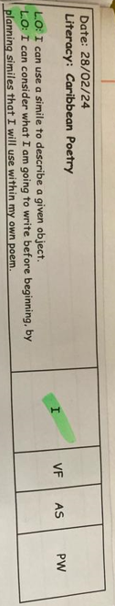
Partially met
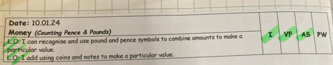
Not met
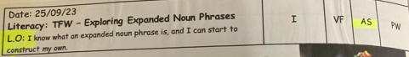
Support code key
I | Independent
VF | Verbal feedback
AS | Adult support
PW | Partner work
GW | Group work
WC | Whole class

The Governors and Senior Management Team are committed to ensuring that the demands of marking and feedback to aid student progress are appropriately balanced with staff workload. There is an expectation for all work to be acknowledged but staff are encouraged to use their professional judgement as to the most suitable method of feedback to use.

Evidence of feedback and marking in both children’s books and our learning environment could include:
Basic acknowledgement marking | highlighting of learning objective and/or ticking and stamping
Verbal feedback | here teachers have communicated verbally with a child this is evidenced alongside the specific area for improvement in their work and you should expect to see either an amendment in green pen or some form of pupil voice via speech bubble or post it.
Use of marking codes | These codes are written in red pen and show where in their work an adjustment needs to be made.
Written prompt | This marking is more commonly seen in Upper KS1 and KS2
Peer or self-marking

Use of marking and support codes
Support codes are used in an age appropriate fashion across our EYFS, KS1 and KS2 to support children in identifying targets and areas for improvement.
In EYFS or KS1 this may look like this
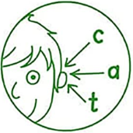 | 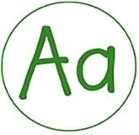 |  |  | 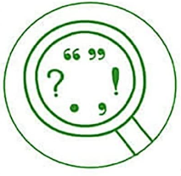
Sound out or  Look at spelling | Use a capital letter | Write on the line | Use finger spaces | Look at your punctuation

In Upper KS2 and KS2 this is likely to look like this.
| | Finger space missing
P | Punctuation
// | Paragraph missing/wrong
Sp | Spelling
? | Unclear
^ | Omission (something is missing)
 | Incorrect answer
 | Next steps

Peer- or self-marking
Although used less regularly children are encouraged to self-evaluate their own learning as well as the learning of their peers. This is an important part of every child’s learning journey and enables them to develop as responsible and reflective learners. Children identify successes against the learning objective and gauge how effectively they, or their peer, have applied elements of a jointly created success criteria/toolkit? Pupils are encouraged to articulate areas of strength and development to their peers positively and respectfully by stating what has gone well and even better if.

In-depth marking
When appropriate, teachers will focus on both successes against the learning objective and areas for improvement by writing a more detailed response in order to address misconceptions, consolidate learning or provide an opportunity for an additional challenge or mastery.
Examples of in-depth marking may include comments such as:
• Prove it…
• Now try…
• Show me…
• Explain in your own words…
• Find your mistake and fix it…
• Uplevel the following…
• Give an example of…
Teachers may also use:
• A question prompt (e.g. ‘what else could you say about the prince’s clothes?’)
• A scaffolded prompt (e.g. ‘What was the monster doing?’, ‘the monster was so angry that he…’)
• An example prompt (e.g. ‘try to use adjectives in pairs: the juicy, green apple; the scrawny, hairless cat. Rewrite your sentence using pairs of adjectives for each noun’)
• A reminder prompt (e.g. ‘remember to always line up your HTO columns. Try it with these calculations…’ or ‘write the paragraph again using some of the emotive language from the working wall’)
In order for the marking to be formative, the information must be used, and acted upon, by the children. Therefore, when work has been marked in depth, time is planned in a future lesson for children to read and write a focused improvement based on the feedback given. Ideally, this would happen when the learning is still current and meaningful. Teachers model this process to the children so that they are clear what the marking and support codes represent and how to respond to in-depth marking.
Spelling, punctuation and grammar
Not all spelling, punctuation and grammar errors will be marked in every piece of writing. However, where spelling, punctuation or grammar is a curricular, or personal, target, then children will be expected to attempt to meet them. When an adult feels that a child can correct a spelling, he or she will indicate the spelling error with the SP code.
Marking in the Early Years Foundation Stage
In Nursery and Reception children receive immediate oral feedback. Marking aids teacher assessment and supports parental understanding as to how their child has achieved developmental milestones, child and teacher led activities. The EYFS use the same support codes as KS1 and KS2. Oral feedback and marking are documented in books and via our online journal Tapestry.
In the Foundation Stage, marking and feedback strategies include:
- Verbal Praise and oral dialogue with children about their play or work
- Stickers and stamps
- Written annotations, short and narrative observations (written)
- Annotation of work and photographs by staff
- Flagged areas of learning against the EYFS framework on Tapestry
- Children beginning to annotate their own work and pictures
Monitoring and Evaluation of the Policy
We believe that children learn best when they receive ‘in the moment’ feedback. By encouraging teachers to mark with children as often as possible there is time to clarify necessary changes in order to progress towards meeting their learning objective and identifying their next steps. Whilst teachers choose the most appropriate method of feedback there is an expectation that children will be exposed to a variety of approaches throughout the academic year. All aspects of learning will therefore be addressed over time. We identify the impact of this policy when we see that feedback and marking have a positive impact upon pupil progress and supports teacher assessment. The consistency of marking and feedback methods are monitored during formative and summative assessment periods, learning walks and subject reviews. Staff meetings also allow time for discussion to ensure that the policy is working effectively.
Ratified by the Governing Body: March 2024
Review Date: March 2026

