Religious Education Policy



Forty Hill CE Primary School Vision for Education:

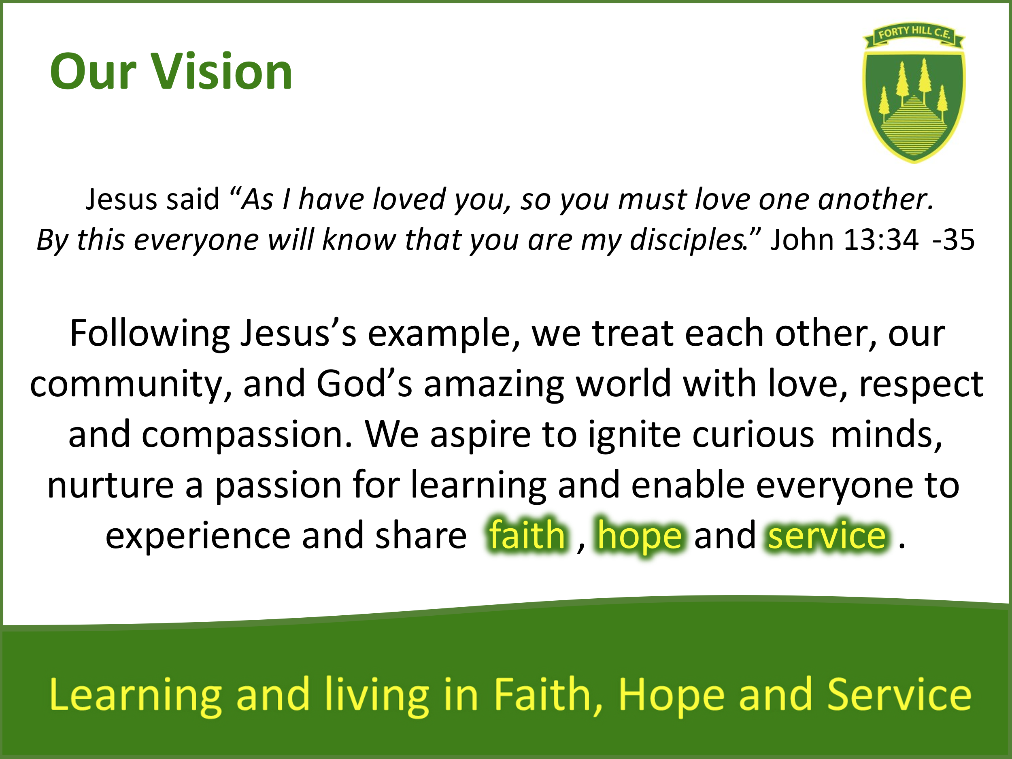

Introduction

Forty Hill C.E Primary School is an inclusive school situated in the heart of Enfield. This policy is intended to assist staff and pupils in developing knowledge and understanding of Religious Education and is set within the context of the Church of England Vision for Education, the Church of England Statement of Entitlement for Religious Education and the school’s theologically rooted vision and associated values.

We have high expectations of all our pupils and deliver a curriculum that is rich and varied, enabling all children to become religiously literate within an inclusive and safe space that promotes critical thinking and celebrates and respects difference. It enables all pupils to develop and encourages them to be thoughtful, compassionate, and active members of society in line with our vision: living and learning in Faith, Hope and Service.

What is R.E
RE is a core and academic subject in church schools that enables pupils to develop their knowledge and understanding of religions and worldviews, recognising their local, national and global contexts. The teaching of RE allows children to understand faith and hope in a Christian context whilst also learning about the beliefs of others. Jesus’s command to love one another is demonstrated practically in the actions of Jesus which also symbolise respect. These values are applied to the teaching and learning of all RE. The subject, supported by safe and open learning environments, provides all pupils with the opportunity to ask questions and begin to express their own views in response to the material they learn about and in response to questions about their ideas. As children learn that a person’s faith can impact their daily decisions, actions and life choices, we seek to foster the connection between love in action and service. RE lessons also provide children with opportunities to reflect upon how their actions affect those around them, promoting a sense of responsibility for the wider world. By learning about, and practicing service, students strengthen their sense of community within the school and beyond. They learn that they are part of a global family, where each unique person has a role to play in making the world a more just and caring place.

Aims of R.E
At Forty Hill CE Primary School, Religious Education is a core subject within which we aim to:
- Enable pupils to know about and understand Christianity as a diverse global living faith through the exploration of core beliefs using an approach that critically engages with biblical text.
- Enable pupils to gain knowledge and understanding of a range of religions and worldviews appreciating diversity, continuity and change within the religions and worldviews being studied.
- Engage pupils with challenging questions of meaning and purpose raised by human existence and experience.
- Enable pupils to recognise the concept of religion and its continuing influence on Britain’s cultural heritage and in the lives of individuals and societies in different times, cultures and places.
- To provide opportunities for pupils to explore their own religious, spiritual and philosophical ways of living, believing and thinking.
(Church of England Statement of Entitlement)

Time allocation

RE is taught weekly in every year group. In our Early Years Foundation Stage, children are automatically introduced to the concept of being unique, and belonging in a new context, as they introduce themselves during transition. They also begin to recognise that people have different beliefs and celebrate special times in different ways as they share their experiences of religious and cultural communities and practices. We create additional time to learn about and reflect upon the festival of Diwali, Channukah and Eid. We follow the LDBS plans for EYFS in Nursery and Reception. All Children in EYFS, KS1 and KS2 will study Christianity alongside another world faith details of which can be found on our R.E. curriculum overview. Additional time is given to the teaching and understanding the Christian core concepts of Incarnation and Salvation through Focus weeks at Christmas and Easter.

The Legal Position of Religious Education
Parents have the right to withdraw their child from Religious Education or Collective Worship. We would hope however, in the light of our inclusion policy and home school agreement, that this will not be necessary, and parents who have specifically chosen our school will wish their child to fully participate in Religious Education and Collective Worship. Parents who wish to withdraw their child/children from RE are encouraged to discuss this with the Headteacher during which arrangements for their alternative care and supervision time will be outlined and agreed.

How we teach R.E

At Forty Hill CE Primary School, RE is seen as a core academic subject and as such is given the same status as other core subjects within the National Curriculum and the school’s theologically rooted vision

We follow the London Diocesan Board for Schools (LDBS) Religious Education Curriculum which encourages children to become confident in the following disciplinary knowledge and skills: Theology (Believing), Philosophy (Thinking), and Human Social Science (Living).

The aims of the syllabus are as follows:
- To enable all children to become religiously literate.
- To ensure RE enables all children to live life in all its fullness – vision for Education (Church of England)
- To offer a systematic enquiry- based approach to the teaching of RE so that the following skills in children can be developed:
- Ability to be critical thinkers
- Ability to engage critically with texts
- Ability to ask deep and meaningful questions
- Ability to make connections within, and across religions and worldviews.
- Ability to reflect, respond and express their own religious, spiritual and/or philosophical convictions.
- Ability to make their own choices and decisions concerning religion and belief based on a deep knowledge and understanding of religions and worldviews belief systems, values and practices.
To offer units of learning that:
Are rooted in theological concepts, strong subject knowledge and content.
Offer a balanced curriculum which enquires into religions and worldviews through theology, philosophy and the human and social sciences.
Offer sequential learning both in terms of knowledge and skills across the primary age range.
- Offer motivating, engaging and creative lessons for all children.
- Provide opportunities for children to develop empathy towards people of similar or differing religious or world views to their own.

To ensure the teaching of RE supports and enhances:
- The Christian vision of our school.
- Contributes significantly to the spiritual, moral, social and cultural development of our pupils
- Takes note of the Religious Education Church of England Schools – Statement of Entitlement
- The Church of England’s vision for Education, that every person deserves to live a ‘life in all it’s fullness’.

Within every unit, the sequence of learning is as follows:
Enquire: Engage with the big and subsidiary All questions will be rooted in one of the disciplines of RE: Theology, philosophy or human/social science.

Investigate/explore: What is the religious content and context being explored? How deep can we go? This ‘explore’ stage of the enquiry is where pupils will be primarily learning about religion and belief. In order for this to be effective there are some strategies that can be used to ‘deepen’ learning:
- Interpreting and analysing sacred texts
- Using challenging and controversial questions
- Extended pieces of writing
- Discussion which continually asks, ‘Have we gone deep enough yet?
- Pupils engage with authentic religious believers (face to face, via webcams, podcasts, video, skype etc)
- Grapple with complex theological concepts, questions and issues

Evaluate/communicate: What is our understanding of the concept? What impact does the concept have on the lives of believers? What difference does this belief/practice make? The aim of this part of the enquiry is to encourage dialogue about the learning. Children use skills of analysis and evaluation. The focus is on the impact of the belief or practice on the religious or belief community being studied.

Reflect on/express: What is our understanding and response to the enquiry question when considered from the perspective of the faith and belief traditions that have been encountered? What is our personal response? It is always based on knowledge and understanding, not values or SMSC development.
Early Years Foundation Stage
Young children are constantly exploring the world around them; their intrinsic sense of awe and wonder provides endless opportunities to explore big questions and develop a sense of spirituality. Whilst all areas of learning and development in the Early Years Foundation Stage (EYFS) are important and inter-connected, RE is planned for and taught through the specific area of Understanding the World with a mixture of adult led and child-initiated learning. In Nursery this begins with the sharing of personal experiences where children start to understand that people have different beliefs and practices alongside a variety of stories. Children will become familiar with the Christian symbol and key religious festivals within the Christian calendar as they attend whole school services and visit Jesus Church. They will begin to explore the nature of God and the life and teachings of Jesus as they read the Bible and become familiar with some of Jesus’s parables. As a result of explicit teaching and shared discussion we aim for children to understand they are part of a diverse world and develop religious vocabulary to be able to communicate their own thoughts, feelings and beliefs. In Nursery and Reception children begin to follow the LDBS syllabus and develop an awareness of the big story of the Bible and some of the core concepts of Christianity. In this setting the children will become familiar with the format of a Big Question which is explored through a specific and sequential question in each lesson. Children will continue to broaden their religious vocabulary to articulate their understanding and ideas. A variety of cultural and religious stories are used as a stimulus in both of our EYFS settings to promote thinking and questioning with each child’s religious journey being captured in RE Floorbooks or Tapestry.

Religious Education in Key Stage One
By the end of Key Stage One, we aim to ensure that all children have an understanding of the main beliefs and teachings of Christianity, Judaism and one other world faith, Islam, at an age-appropriate level. Children will have begun to recognise similarities and differences within and between religions and have an awareness of what it means to have a religious or non-religious worldview. Children will have a religious vocabulary appropriate to their age and be able to ask important questions about life. They will be able to recognise that others may have a different viewpoint to their own.
Religious Education in Key Stage Two
In Key Stage Two, we aim to enhance children’s previous learning and enable them to develop a greater understanding of core beliefs and theological concepts of Christianity. Children will be given the opportunity to study three further world faiths.

By the end of Key Stage Two, our aim is that children will be religiously literate at an age-appropriate level. Pupils will be able to use confidently a wide range of religious and philosophical vocabulary. They will have a solid understanding of Christianity as a diverse and global living faith and other world faiths studied and know what the impact of belonging to a faith has on a believers’ life. We also want our children to have a solid understanding of what it means to have a religious or non-religious worldview. We aim for our children by the end of Key Stage Two, to be able to express and justify their own views with confidence. We aim for them to be critical thinkers and be able to engage critically with Biblical and other sacred texts. We want our children to be able to draw on their religious knowledge to formulate their own opinion and understanding of the world in which they inhabit and how they can positively impact it.

Access to the Curriculum
At Forty Hill we understand that each child is unique, and all children participate in RE lessons. We plan lessons to incorporate the needs of all learners and seek to provide additional or adaptive teaching resources to ensure that every child can participate fully and to reach their potential. Each lesson children re-cap prior learning, build new knowledge and throughout their unit make progress. All children are treated with equal respect, worth and value regardless of race, colour, background, gender, sexuality, learning need or learning ability.

Impact of the LDBS syllabus
- Children will be able to hold a balanced and well-informed conversation about religion and worldviews. (Religious literacy)
- Children will make good or better academic progress from their starting points as a result of a rich and engaging RE curriculum.
- Children will be able to reflect, respond and express their own religious, spiritual and/or philosophical convictions.
- Children will be able to make their own choices and decisions concerning religion and belief based on a deep knowledge and understanding of religions and worldviews, belief systems, values and practices.
- Children will have developed a deeper understanding of what it means to live life in all its fullness.

Environment and Resources
At Forty Hill our goal is to provide a rich, stimulating and engaging environment in which Religious Education can take place and fosters deep questioning and thinking. Resources are kept in a central store area in boxes relating to faiths. This includes collections of artefacts, posters, and resources to support retelling and promote discussion and questioning. All resources are labelled appropriately to ensure ease of access and use. Resources are audited by the RE Lead to ensure staff and pupils have the resources they need for specific units of learning and in conjunction with guidance received at LDBS Network Meetings. We provide professional development to staff through allocated staff meeting sessions. We plan and organise our learning environments to include differentiated tasks and a variety of learning activities to ensure that all children can access the curriculum. We promote both independent and collaborative working and place great emphasis on the role of talk within the classroom to support understanding of vocabulary and the organising of thinking. Opportunities for dialogue also enables us to capture a child’s knowledge and understanding where it is not always reflected in written form. Children enjoy handling artefacts and are supported to do so respectfully. We value the importance of enrichment opportunities that provide experiences with a living faith instead or real-life resources, including class trips and visitors. We pride ourselves on the working relationship we have with our local parish and the wider community.

Planning, Assessment, Recording, Monitoring and Evaluation

Planning
- The LDBS syllabus is designed to have content that is two thirds Christian and one third other major world faiths.
- Teachers use the LDBS units of learning and adapt them so that lessons are tailored to the needs of the children
Assessment
- Teachers familiarise themselves with the substantive knowledge children should know by the end of each unit.
- Teachers familiarise themselves with the yearly development that children should make in the following disciplinary knowledge and skills: Theology (Believing) Philosophy (Thinking) Human Social Science (Living)
- Teachers introduce the units Big Questions and explain that each lesson’s specific question provides an opportunity to build knowledge and develop skills to be able to answer it.
- A pupil’s knowledge and skills are monitored each lesson during re-cap and specific lessons tasks. Pupil voice and a child’s learning journey can be captured via scribing, photographs, group or individual work.
- Specific assessment tasks do not have to be carried out, unless incorporated into the plans or deemed appropriate by the Class Teacher.
- Working walls should be interactive and at the end of each lesson/unit provide a plethora of additional evidence
- Time should be given for children to peer assess their use of specific vocabulary during a task and/or at the end of a unit.
- Next step questioning to ‘go deeper’ whether that be enabling a child to meet working towards, progress to expected or move onto to Greater Depth.
- Teachers assess each child’s progress at the end of each unit using the judgements of working towards (WT) Expected (E) or Greater Depth ( GD) to inform future planning.
- Children’s progress in RE to be discussed during Pupil Progress Meetings.
Recording
- Each child’s religious journey should be documented and captured across all year groups in a variety of ways.
- Pupil voice - written individually or scribed, this can be placed in the floor book and/or individual work books (Y1-6) Floorbooks or Tapestry (EYFS)
- Working walls should be interactive and display the voice of the children alongside specific instruction
- Group or individual work can be both written or creative (photos, art, drama, music)
- Ipads can be used to record the responses of those who can articulate their understanding verbally but not in written form and should be stored digitally.
- Scaffold and support the work of those who need help writing through mixed ability pairing or teacher support.
- Children should respond to next step questions to clarify or ‘go deeper’.
- Discussion based lessons can be evidence in Floorbooks and group or individual tasks in work books

Monitoring and evaluating
- Learning walks
- Lesson observation
- Book looks
- Cross School moderation - in order to bench mark standards beyond the school
- Internal data - which is tracked, analysed, discussed with staff and reported back to the full governing body termly. (Action points are then generated to support progress through pupil intervention, targeted teacher training / support etc.)
- Pupil progress meeting discussions
- Pupil voice

Special Educational Needs and Disability
Every effort must be made by teachers to ensure that pupils with SEND are enabled to participate as fully and as effectively as possible in religious education. Teachers should take specific action to enable the effective participation of pupils with SEND through effective planning. Potential areas of difficulty should be identified and addressed at this stage.

Religious Education offers pupils with SEND opportunities to:
- develop their self-confidence and awareness
- understand the world they live in as individuals and as members of groups
- bring their own experiences and understanding of life into the classroom
- develop positive attitudes towards others, respecting their belief and experience
- reflect on and consider their own values and those of others

Parent and Carers
At Forty Hill we recognise that a partnership between the school and parent(s)/carer(s) is essential to help children flourish. Each Class produces a half term overview which shares their RE Big Question and a synopsis of the unit. This should support conversation at home and homework tasks often link to this area of learning. In addition to this additional information can be provided upon request. We also have a group of parents who are happy to come into school to participate in RE lessons, by invitation when applicable, and welcome new offers of support.

Parents are also invited to collective worship activities and Church services (see the Worship policy) so that children can share their learning and achievements. Finally, parents/carers are kept informed and are encouraged to discuss their children’s learning during parent consultations and an annual report is sent out detailing their progress.

Role of the RE subject leader
The subject leader will:
- Ensure that all pupils receive their legal entitlement of Religious Education.
- Ensure RE provision reflects the Church of England Statement of Entitlement.
- To keep up to date with developments in the area of Religious Education through reading, attending LDBS RE network meetings and training and by forming links with other Church of England schools.
- To monitor and evaluate the planning, teaching and assessment of Religious Education across the school in collaboration with the leadership team.
- To support staff in the teaching of Religious Education across the school through team planning, teaching and moderation.
- To lead the review of the policies and impact of the syllabus on raising standards.
- To plan and lead INSET and CPD to build on the staff’s knowledge and practice of effective Religious Education teaching.
- To work closely with the senior leadership team to identify CPD needs of individuals, teams and the whole school.
- To regularly review and keep up to date the school’s self-evaluation document for RE that forms part of the SIAMS ongoing self-evaluation document.
- Oversee the RE budget and monitor RE resources to ensure they are kept and stored respectfully and replaced where necessary.
- Ensure there is a school protocol, that covers safeguarding procedures and a suitability process, for when visitors are invited into RE lessons.

Evaluation/Review:

This policy is reviewed regularly by the RE leader in consultation with the Headteacher and ratified every two years by the Governing Body.

Accepted by the Governing Body: 13.2.2025
Review Date: February 2027

