

London Borough of Enfield

Health and Safety Policy

Forty Hill CE School

October 2024

 | Name |  | Signature |  | Date
Prepared by: | Paul Bishop |  | 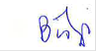 |  | Feb 2008
Checked and Reviewed by: | Paul Bishop |  | 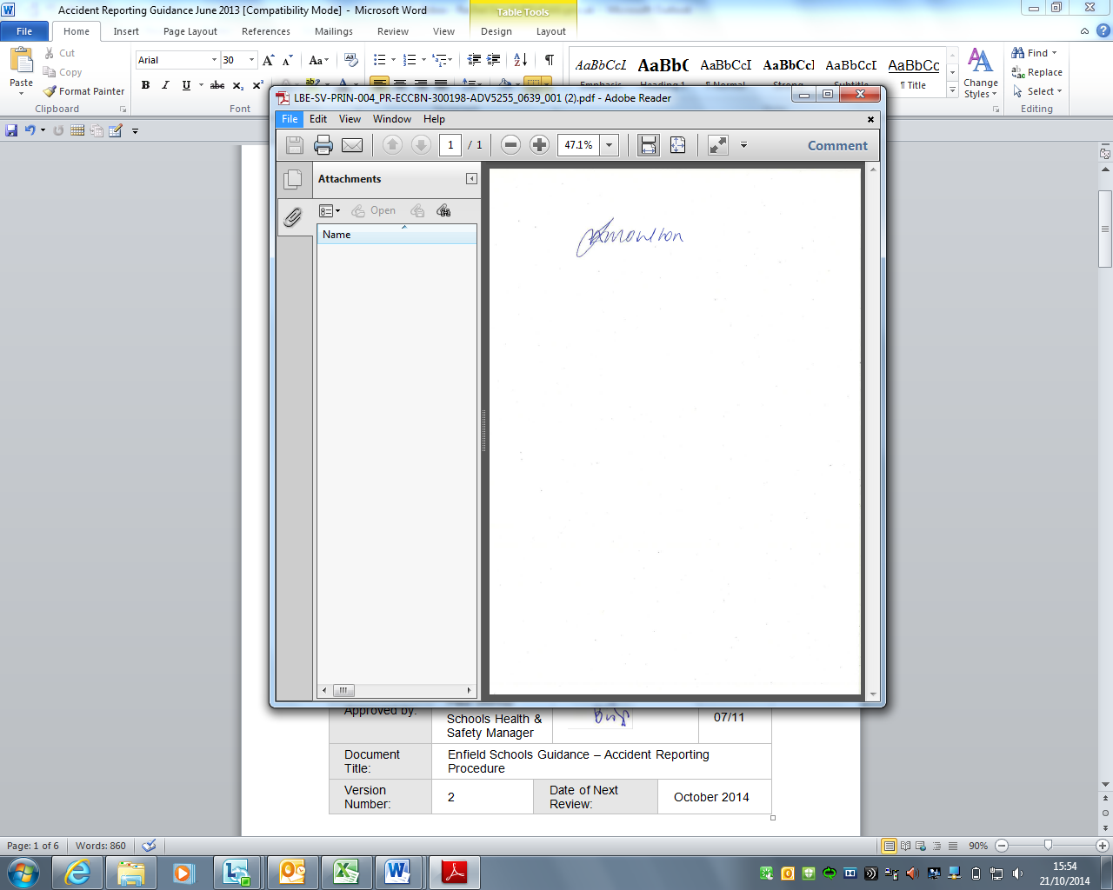 |  | Jul 2024
Approved by: | Peter Nathan |  | 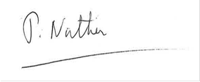 |  | Jul 2024
Document Title: | Health and Safety Policy for Forty Hill CE School
Version Number: | 4 | Date of Next Review: |  | Jul 2026

This page is for Schools Health & Safety Team document control only.
This plan is subject to ongoing change and will be updated as and when required.

Governing Body

The Governing Body will do all that is reasonably practicable to ensure the health, safety and wellbeing of staff, pupils and visitors, including contractors, and others who may be affected by the school’s activities. To this end, we believe in achieving our aims in partnership with all interested parties. We are committed to complying as a minimum with our legal responsibilities, but we are seeking to continually improve our health and safety performance in line with best practice. We will maintain and continually review an effective health and safety management system, which we consider to be an essential part of a high performing school.

It is the intention of the Governors and Headteacher that the established health and safety policies, guidance and procedures issued by London Borough of Enfield shall be followed and developed locally to meet the specific needs of Forty Hill school. The aim is to ensure that health and safety becomes an integral part of managing school activity. This policy will be reviewed annually by the Governing Body, and employees will be consulted prior to any amendments being made.

- a safe and healthy working environment with adequate control of health and safety risks arising out of our activities
- an effective organization to implement the policy
- full consultation with our staff on matters affecting their health and safety
- effective communication throughout the school on health and safety matters
- information, instruction and supervision is provided
- all staff are competent to carry out their work and meet their health and safety responsibilities; and the provision of adequate training and development
- risk assessments are undertaken and the necessary controls implemented
- the effective management of contractors
- competent advice will be obtained when that is not available within the school
- effective monitoring and review of the implementation of the policy and health and safety performance
- periodic independent auditing is undertaken
- adequate resources are provided to implement this policy

The governing body as employer recognises its overall responsibility for health and safety. However, high standards can only be achieved with the full involvement of the school community. Staff must meet their responsibilities as laid down in the policy and work in accordance with the safe working procedures.

The governing body will review this policy annually.

Signed: Chair of Governors

Date:

ORGANISATION FOR IMPLEMENTING THE POLICY

RESPONSIBILITIES

Head

The Head is responsible for the overall implementation of this policy throughout the school. This includes day-to-day responsibility for maintenance and development of safe working practices and conditions for all staff, pupils, visitors and any other person using the premises or undertaking activities under the school's control. In particular, the Head will:

- nominate a senior manager as health and safety coordinator
- ensure subordinate managers meet their health and safety responsibilities
- ensure the arrangements for consultation with staff are implemented and chair the safety committee
- ensure effective communication of health and safety matters
- ensure requirements with regard to staff competence are met
- ensure health and safety standards, school health and safety procedures/codes of practice are implemented
- ensure risk assessments are carried out
- undertake risk assessments in relation to directly managed staff (e.g. stress risk assessments)
- ensure health and safety monitoring is undertaken, including:
(i) incident reporting and investigation
(ii) specific equipment and premises inspections
(iii) termly inspections
(iv) implementing the school’s annual monitoring checklist
(v) health and safety in staff appraisals
(vi) ensuring an annual report is provided to the governing body
(j) make recommendations to the governing body in relation to external independent audits
(k) report to the governing body any health and safety issues that cannot be resolved.

Senior Management Team

The senior management team will support the Head with regard to the overall management of health and safety in the school. This includes:

- providing leadership by ensuring health and safety is considered as part of every decision
- considering the health and safety impact of new initiatives informing the Head about any health and safety issues that affect the school
- agreeing strategic health and safety initiatives
- monitoring the overall implementation of the school’s health and safety policy in their areas of control and agreeing the annual health and safety report.

School Health and Safety Coordinator

The Health and Safety Coordinator is responsible for the overall coordination of health and safety throughout the school on behalf of the Head. Responsibilities include:

- coordinating all aspects of health, safety and wellbeing policy and practice
- liaising with safety representatives and attending the safety committee
(c) disseminating health and safety information
(d) coordinating accident reporting procedures
(e) coordinating emergency evacuation procedures
(f) ensuring health and safety matters raised by staff are dealt with
(g) maintaining a central file of health and safety procedures and other relevant information;
(h) monitoring implementation of the policy by:
(i) ensuring heads of department undertake inspections
(ii) ensuring incidents are investigated
(iii) reporting 'reportable' incidents to the Health and Safety Executive.
(iv) managing the schools annual monitoring checklist
(v) making recommendations to the Headteacher about an independent audit
(vi) reporting health and safety issues that cannot be resolved to the Head/governing body.

Other Managers

(Including Heads of Department, Managers of Non-Teaching Staff.)

Managers are responsible for implementing this policy in their area of control. This includes:

- ensuring staff meet their health and safety responsibilities
- consulting with staff on matters affecting their health and safety
- communicating health and safety information to staff
- assessing staff competence and ensuring appropriate training and development
- ensuring school-wide health and safety standards, and school health and safety procedures/codes of practice, are implemented
- ensuring risk assessments are carried out
- ensuring safe working procedures and codes of practice are prepared for activities under their control
- undertaking risk assessments in relation to directly managed staff
implementing monitoring arrangements, such as:
  - incident reporting and investigation
  - specific equipment/premises inspections
  - termly inspections
  - the schools annual monitoring checklist
  - including health and safety in staff appraisals
  - reporting any health and safety issues which cannot be resolved to the health and safety coordinator/Head.

All Members of Staff

All members of staff are responsible for:

- taking care of their own health and safety and the health and safety of others affected by their actions
- co-operating with the governing body by following the schools safe working procedures and meeting responsibilities laid down in this policy
- reporting health and safety hazards and any inadequacies they identify in health and safety procedures to their line manager or the school health and safety coordinator
- undertaking any health and safety training/development identified as necessary
- using work equipment in accordance with safe working procedures, instructions and training
- not making unauthorised or improper use of equipment
- ensuring a risk assessment is undertaken when carrying out projects or new activities
- reporting health and safety incidents, and near misses, in accordance with the schools reporting procedures.

Safety Representatives

Safety representatives do not have responsibilities under this policy. However, they have functions as laid down in the Safety Representatives and Safety Committees Regulations 1977 (SI 1977 No. 500). Reasonable time will be provided to enable safety representatives to carry out their functions subject to the exigencies of the service. This should be arranged with their line manager and the health and safety coordinator.

Where no union representation for safety is available under the Safety Representatives and Safety Committees Regulations 1977, the Health and Safety (Consultation with Employees) Regulations 1996 will apply and employees will be consulted directly as individuals, or through elected health and safety representatives (known as “representatives of employee safety” in the Regulations), or a combination of the two.

ARRANGEMENTS FOR IMPLEMENTING THE POLICY

Consultation with Staff

Health and Safety Committee

The school has established a health and safety committee, which meets termly. It is chaired by the Head and includes management representatives and safety representatives elected by the staff. The committee facilitates consultation on school-wide issues, such as codes of practice. It is also a forum where safety representatives can raise issues concerning health and safety and where unresolved issues can be addressed.

Local Consultation

Line managers will consult directly with staff on health and safety issues relevant to a particular department or work area.

Note: If the school does not have a safety committee, e.g. where the school forms part of a larger organization, such as a group of academies, that should provide this forum. Alternative arrangements for consultation on school-wide issues will still be required and these should be stated here.

Health and Safety Procedures

Use the appropriate terminology for the school, e.g. "code of practice", "health and safety manual", etc.
The school has drawn up health and safety procedures and arrangements covering school-wide issues. These were drawn up on the basis of a risk assessment and include the following required control measures.

Display Screen Equipment

Indicate arrangements for undertaking display screen equipment assessments e.g. who will carry them out - they will need to be competent, the procedures they will follow, arrangements for eye and eyesight testing, etc.

Educational visits

The role of the educational visit’s coordinator, arrangements for seeking approval - both within the school and where appropriate from the LA, risk assessments, pre-visits, staff ratios, etc.

Traffic management

Arrangements for ensuring separation of pedestrians and vehicles particularly at the beginning and end of the school day. For example, the responsibilities of the person on duty, how the arrangements are communicated to staff, pupils and parents.

Management of contractors

Arrangements for the selection, management and monitoring of competent contractors, including the arrangements for securing competent advice when that is not available within the school.

Dual use

Arrangements for managing dual use facilities, eg arrangements for assessing whether particular activities can be safely accommodated, making sure the premises are properly prepared prior to the booking, ensuring the instructor is competent.

First aid

Who the first aiders are, arrangements for their training, arrangements for contacting them, location of first-aid boxes, responsibility for first-aid boxes.

Fire and emergency procedures

This should form the basis of the evacuation procedures posted throughout the school. It will also include the role of the person in charge - normally the Head but it should include the arrangements when he/she is not on site; the roles of all staff; how the evacuation will be conducted; arrangements for ensuring everyone has left the building - either a roll call or a "sweep" of the building by nominated members of staff, action on discovering a fire or other incident, etc.

Risk Assessments

The health and safety procedures referred to above were drawn up on the basis of an assessment of the risks. Some require further detailed assessment of the activity (eg display screen equipment, educational visits); in these cases the relevant member of staff must undertake the assessment. Others are generic risk assessments and where activities comply with the assessment there is no need to record a separate assessment. Where an activity differs from the generic assessment, the person responsible for the activity must ensure there is a re-assessment to account for these variations. Where this is minor it may be no more than adding a simple local variation to the generic assessment. Heads of department and other line managers are responsible for ensuring risk assessments are drawn up and implemented for activities carried out under their area of control. For many such activities, line managers should arrange for a departmental health and safety procedure to be drawn up as a generic assessment, although, again, local variations may be needed when it is necessary to deviate from the generic assessment.

Fire and emergency procedures

This should form the basis of the evacuation procedures posted throughout the school. It will also include the role of the person in charge - normally the Head but it should include the arrangements when he/she is not on site; the roles of all staff; how the evacuation will be conducted; arrangements for ensuring everyone has left the building - either a roll call or a "sweep" of the building by nominated members of staff, action on discovering a fire or other incident, etc.

Appendix: Individuals with Specific Responsibilities in the Policy and Access to Information on Health and Safety

Responsibility | Name
Head | Jonquil Izard
Senior Management Team | Lauren Saunders  Helen Dale  Susie Munt
Health & Safety Co-Ordinator | Paul Bridgeman (Site Manager
Other Managers  (include (included heads of department, non-teaching staff such as bursar, specialists such as Premises Manager and Educational Visits Coordinators) | Celia Vial (Welfare & Admin)  Claire Behling (SBM & EVC)
Safety Representatives | Jonquil Izard
First Aiders  Appointed Persons  Location of First Aid Boxes  Name and address of nearest hospital | Celia Vial (All support staff are first aid trained)  Celia Vial (Welfare)  Welfare Room  Chace Farm Hospital (Urgent Care)  127 The Ridgeway, Enfield EN2 8JL  North Middlesex Hospital (A&E)  Sterling Way, London, N18 1Q
Fire Safety Manager / Evacuation Officer  Location of Fire Log Book  Fire Assembly Point  Time of weekly Fire Alarm Tests | Celia Vial, Jonquil Izard, Paul Bridgeman,  Claire Behling  Site Managers Office  KS2 Playground  7am Monday Morning
Asbestos (Appointed Person to use AMS Webtracker) | Paul Bridgeman (Site Manager)  Jonquil Izard (Headteacher)
Procedures reporting hazards  (Name and/or contact arrangements | Book in Premises Manager Office Health and Safety Governor Walk Around
Legionella (Appointed Person) | Paul Bridgeman (Site Manager)
Premises Manager/Site Manager | Paul Bridgeman (Site Manager)

Documents relating to this Policy are listed below along with the locations in which they can be found.
Documents | Location  (e.g. Office, School Website etc.)
Fire Log Book | Head’s Office/Staff Room
School Policies | Head’s Office
Asbestos Management Plan (to include the following)  - Asbestos Site Plan  - Asbestos Register  - Asbestos Communication Plan  - Asbestos Survey Reports | School Office
Legionella Risk Assessment | School Office
Staff Training Plan (SH&ST Training Programme) | School Office
First Aid Book | Welfare Office
Accident/Incident Reporting Guide | School Office
COSHH Assessments | School Office/Site Office
Risk Assessments | School Office
Responsible Persons Premises Log | School Office
Education Visits Guide | School Office

