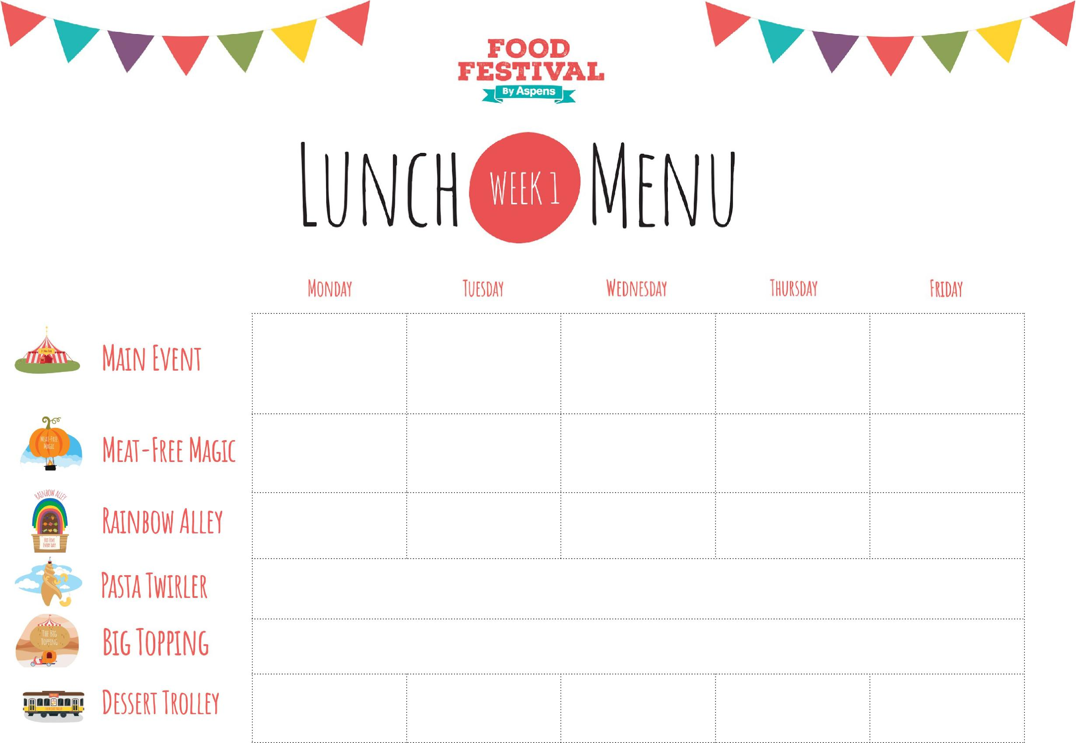
Pudding
Marble Sponge Cake
Baked
Mac n Cheese
with a
Crispy Crumb
Topping
Mild Chicken Curry
with
50/50
Whole Grain Rice
Chicken Sausages &
Red Onion
with
Roast Potatoes
& Gravy
Pizza Margherita with
Potato Wedges
Golden Fish
Fingers or Sausage
& Chips
Vegetarian Dish
Creamy Broccoli & Cheddar Pasta
Veggie Dhal Curry
with 50/50
Whole Grain Rice
Cheesy Leek
Glamorgan
Sausages with Roast
Potatoes & Gravy
BBQ Drizzle
Pizza
with
Potato Wedges
Veggie Fishless Fingers & Chips
Vegetables and Salads
Mixed Salad
or
Carrot Sticks
Green Beans
or
Cucumber
Broccoli
or
Tomato Salad
Peas
or
Carrot Sticks
Baked Beans
or
Shredded Lettuce
Topped Pasta
Hot Tomato Pasta with Hidden Veggies
Crispy Skin Jackets with Cheese or Beans
Filled Jacket
Vanilla Ice Cream
Lemon Cookie
Fruity Flapjack
Jelly & Fruit Slices
Meat Dish
Spring / Summer 2023:
20/2, 13/3, 3/4, 24/4,
15/5, 5/6, 26/6, 17/7

Chicken Bangers
& Mash
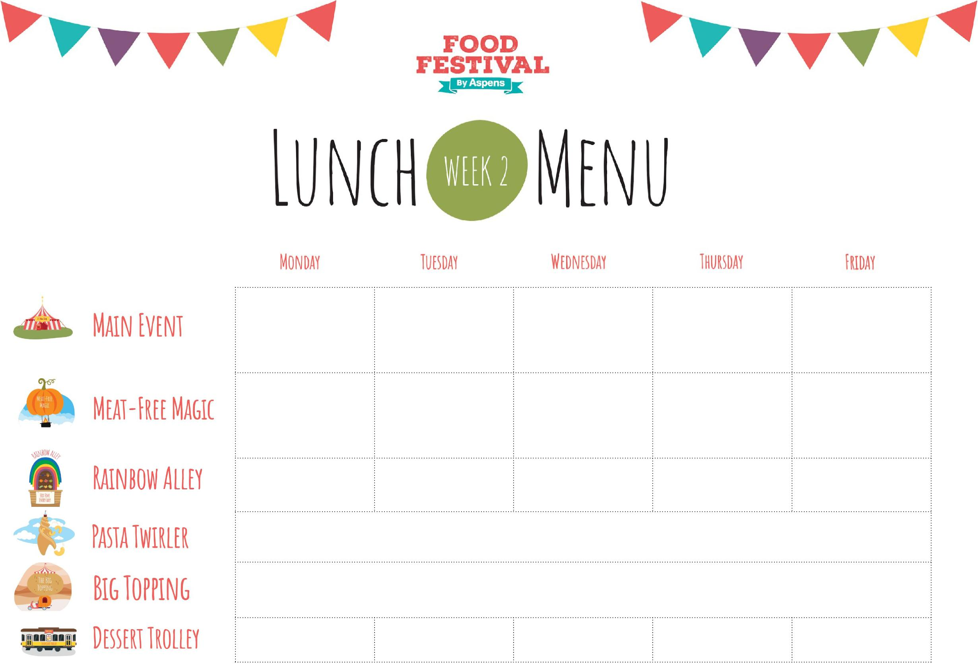
Cheesy
Sweetcorn Pizza
with
Potato Wedges
Chicken &
Sweetcorn Pie
With Roast Potatoes
Chow Mein Veggie Noodles
Golden Fish
Fingers or Sausage
& Chips
Vegetarian Dish
Veggie Lentil & Onion Pie PRI
Vegetables and Salads
Baked Beans
or
Sweetcorn Salad
Green Salad
or
Shredded Lettuce
Savoy Cabbage
or
Carrot Sticks
Green Beans
or
Shredded Lettuce
Baked Beans
or
Shredded Lettuce
Topped Pasta
Hot Tomato Pasta with Hidden Veggies
Crispy Skin Jackets with Cheese or Beans
Filled Jacket
Orange Jelly
Apple Sponge
Rhubarb Apple Crumble
Oaty Cookie
Vanilla Ice Cream
Pudding
Veggie Bangers &
Baked Bean
Potato Bake
Pizza Margherita with
Potato Wedges
Chinese Omelette
(Egg Foo Yung)
& Mixed Rice
Veggie Fishless
Fingers
with Chips
Meat Dish
Spring / Summer 2023:
27/2, 20/3, 10/4, 1/5,
22/5, 12/6, 3/7, 24/7

Chicken Hot Dog
with
Potato Wedges
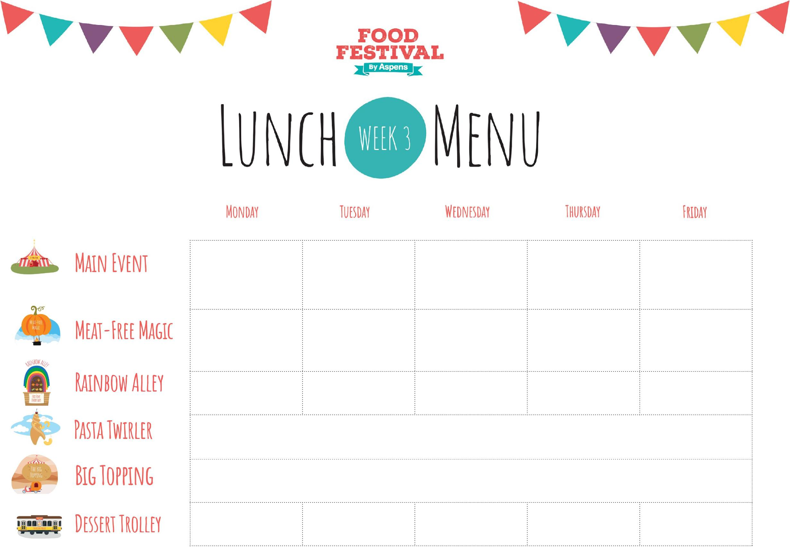
Mild Veggie Korma with Whole Grain Rice
Classic
Cottage
Pie
Veggie Supreme
Pizza
with
Potato Wedges
Golden Fish
Fingers or Sausage
& Chips
Vegetarian Dish
Vegetables and Salads
Green Beans
or
Shredded Lettuce
Peas
or
Carrot Sticks
Carrots
or
Tomato Salad
Broccoli
or
Cucumber Salad
Baked Beans
or
Shredded Lettuce
Topped Pasta
Hot Tomato Pasta with Hidden Veggies
Filled Jacket
Crispy Skin Jackets with Cheese or Beans
Pudding
Apple Strawberry
Crumble Jelly
Watermelon Wedge (85g)
Vanilla Ice Cream
Vanilla Cookie
Cheesy Bean Wrap with Potato Wedges
Sweet Potato
Chickpea Balti with
Whole Grain Rice
Veggie
Cottage
Pie
BBQ Drizzle
Pizza with
Potato Wedges
Veggie Fishless Fingers with Chips
Meat Dish
Spring / Summer 2023:
27/2, 20/3, 10/4, 1/5,
22/5, 12/6, 3/7, 24/7

